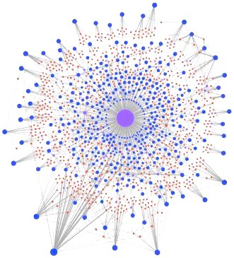

Synthetic Biology in the United States

A Brief History of an Emerging Innovation System

David Rejeski
Global Fellow
Wilson Center

February 2017
Updated July 2017

Acknowledgments:

I was lucky. I had a front seat during the development of a new field — synthetic biology. Not being a scientist, I had not expected those in the field to open their arms to a foreigner with obvious leanings towards the often maligned and un-scientific field of public policy. But it happened. Dozens of people took the time to talk to me, in person or by phone, about their involvement in the field, their hopes, and their concerns.

My special thanks to Paula Olsiewski of the Alfred P. Sloan foundation, who supported the Synthetic Biology Project, myself and my staff, at the Woodrow Wilson Center for eight years.
Special thanks also to Drew Endy, who, like a magician pulling rabbits from a hat, seemed to have an endless library of important historical documents and photos he was willing to share. Tom Knight and Peter Carr reviewed early versions of the history section and provided valuable feedback.

Thanks to my colleague at the International Institute of Applied Systems Analysis, Leena Ilmola, who integrated me into the proposal for the Finnish Academy, an opportunity I would have certainly missed.

This story is my construction and I take responsibility for the interpretation, including any errors or failures of inclusion. Maybe we can make it better.

Dave Rejeski
Washington, DC

The research leading to these results has received funding from the Strategic Research Council at the Academy of Finland under grant agreement no: 293446 - Platform Value Now: Value Capturing in the fast emerging platform ecosystems.

Introduction, or Lost in the Revolutions

How many industrial revolutions have there been? This is not a trick question. Given the preponderance of historical data, this should be a relatively easy question to answer, and an important one, since the answer often shapes our notions of where elusive gains in productivity, wages, and social mobility are to be gained — and the type of public policies that can accelerate these gains. In 2012, the Economist welcomed readers to the 3rd industrial revolution, based on the digitalization of manufacturing with some 3-D printing thrown in for good measure. Quickly thereafter, Germany set the bar even higher with the so-called Industrie 4.0 revolution, which combines flexible manufacturing and automation with the Internet of Things. Playing it safe, the OECD has sidestepped the rush to number each successive production revolution with the concept of NPR — the ‘“next production revolution” which “has the potential to completely change how production will be organized at the global scale…[and] will bring about important economic and social change which have important implications for policy making,”

What is missing from most of these definitions is biology — not biology as a science — but biology as a manufacturing platform — digitally interconnected, increasingly automated, flexible, and cost-effective. What if, as Neri Oxman at the MIT Media Lab noted, “the biological world is displacing the machine as a general model of design.” The focus on the cyber-physical — internet of things, robotic process automation, additive manufacturing — misses the changes, many synergetic, in the cyber-biological realm, where rates of change and cost reductions have been outpacing those that drove the IT revolution.

Today biology goes beyond the “study of complicated things’ as Richard Dawkins put it, to approach what economist and system theorist Brian Arthur defined as “an assemblage of practices and components” which builds on a “collection of devices and engineering practices available to a culture,” or what some have termed a Type 2 ‘innovation’ platform, which, “consists of technological building blocks that are used as a foundation on top of which a large number of innovators can develop complementary services or products.” To paraphrase Stanford University economist Paul Romer, biology today is about better recipes, not just more cooking.

Over the past two years, 75 new companies were created in the synthetic biology field in the US, bringing the total to over 300. In 2015, synthetic biology startups attracted over $500 million globally in venture capital investments, and in 2016, this figure exceeded $1 billion.
Interestingly, funding is coming from people who made their fortunes not in biotech, but in information and communications technologies, such as Eric Schmidt of Google, Jerry Yang of Yahoo, and Peter Thiel of PayPal. One of those startups, Ginkgo Bioworks in Boston, just received $100 million in venture funding to purchase over 400 million base pairs of DNA and explore new design and production paths for bio manufacturing. Jason Kelly, a co-founder of Ginko noted that, “As we get better at designing biology, we’ll use it to make everything, disrupting sectors that the traditional tech industry hasn’t been able to access.” Three thousand miles away in Emeryville, California, Zymergen which is applying robotics and machine learning to microbe engineering, received $130 million in Series B funding from the Japanese telecommunication giant SoftBank.

But none of this happened overnight.

Getting to Now

When Steven Johnson sat down to write his recent book How We Got to Now: Six Innovations That Made the Modern World, he immediately confronts the issue of co-evolution, the challenge of identifying clear paths in dynamic complex systems. He laments early on in the book that the innovations “..set in motion a much wider array of changes…[that] appear constantly in evolutionary history.”

Even if one can pinpoint when a big idea starts, things start to unravel quickly and the navigator is confronted with ever increasing numbers of paths and permutations that call out for our attention. Some researchers have noted that the regularities of such systems are recognizable only in hindsight and with ever increasing difficulty. Winning business strategies have to assume systems under constant development that are never fully specified and subject to constant adjustment and adaptation. Historians trying to understand the origins of the Internet quickly realized that it was a technological, social, and cultural creation, where
packet switching technology combined with the hacker culture and social dynamics of Silicon Valley in the 1960’s. There is little doubt that the Advanced Research Projects Agency (ARPA) played a role in its creation, with the early convening and funding that created ARPANet, but after that the contributions and impacts of actors in the network are harder to identify.

Synthetic biology presents observers with a similar challenge of peering into the mists of history.
The term “synthetic biology’ has relatively clear origins — the Polish geneticist Waclaw Szybaiski used the term in 1974 to describe an emerging phase of molecular biology where scientists could create and add new components to existing genomes or possibly create totally new genomes. But the distance between the name and the emergence of a new field was a long and perilous one.

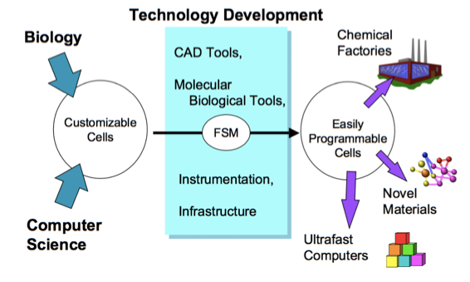
One point stands out on this path. In late summer of 1996, 36 scientists from a variety of disciplines — biology, nanotechnology, computer science, electrical engineering — met at a Victorian mansion in Woods Hole, Massachusetts, owned by the National Academy of Sciences, for a summer retreat run by the Information Science and Technology Program (ISAT) of DARPA (part of the then Information Technology Office). These end-of-summer scientific soirees provided DARPA program managers with a way to explore new funding paths with disruptive potential. The scientists who gathered at Woods Hole were concerned with the limits of controlling inorganic matter (like silicon) at ever smaller scales, crucial in the production of integrated circuits, which led the group to consider biology as a way of ‘creating molecularly perfect materials.’ Concepts that appeared later in the field of synthetic biology such as cellular circuits, genetic switches, biological parts, and programmable matter, were visible here.


Reaching these objectives would require a paradigm shift, turning biology into technology. It would imply injecting an engineering world view into a scientific discipline and then creating tools to allow biology to build other things, from new materials to ultra scale computing systems or novel organisms. It should be noted that the idea of ‘engineering biology’ is what strategic planners have called a BHAG (Big, Hairy, Audacious Goal). The biologists were quick to point that out to the engineers, but the idea served as an aspirational vision of what might be possible and helped focus efforts and resources over a long period of time. Almost twenty years later, DARPA would roll out its new Biological Technology Office with the motto: Biology is Technology.

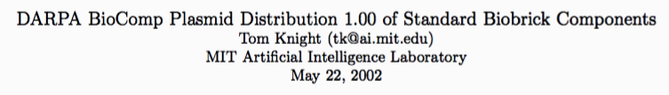
After the 1996 meeting, Sonny Maynard, a program manager in the Information Technologies Office (ITO) at DARPA, made small investments which allowed a group of researchers, including Tom Knight, an electrical engineer at MIT and organizer of the 1996 summer session, to build a microbiology lab in the MIT Artificial Intelligence Laboratory. In May 2001, Knight walked into a DARPA meeting with 30 packets in his hand — the first standardized biological parts, or Biobricks as Knight called them, along with their descriptions (today, the packets and descriptions are in the London Science Museum). One of the people in the room with Tom was a young researcher with a newly-minted PhD in Bioengineering from Dartmouth, Drew Endy, who would join Knight at MIT and later help found the BioBricks Foundation.
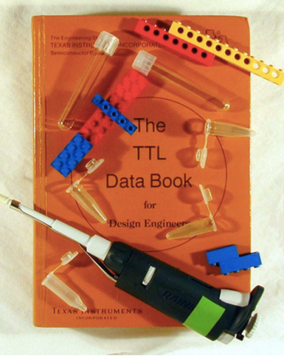
The rationale for standardized parts was already clearly articulated at this point in time in the first BioBricks manual (cover on right): “The lack of standardization in assembly techniques for DNA sequences forces each DNA assembly reaction to be both an experimental tool…and an experiment in and of itself. One of our goals is to replace this ad hoc experimental design with a set of standard and reliable engineering mechanisms to remove much of the tedium and surprise during assembly of genetic components into larger systems.”
DARPA would return to the topic of synthetic biology again in 2003 with a more expanded study involving universities, industry, and government brought together for three workshops and four executive sessions, this time organized by Endy, Richard Murray (Chair of the Division of Engineering and Applied Science at the California Institute of Technology) and Patrick Lincoln (Director of Computer Science at SRI International). The charge to the group was: “to specify enabling technologies that, if developed, would provide a general foundation for the engineering of biology and make routine the creation of synthetic biological systems that behave as predicted.” The goal was to move biology from a ‘discovery’ science to a point where researchers could “…routinely integrate large numbers of well-characterized components to produce many functioning systems.“ The group focused on research to enable three needed transformations:
  - standardization (maintain standards of practice, coordinate parts synthesis, and coordinate system assembly)
  - abstraction of components as a means of managing complexity
  - decoupling of design from fabrication (an approach used to create Very Large Scale Integrated electronics).

In 2003, DARPA was suffering from public and Congressional outrage over a surveillance program reported in the New York Times called Total Information Awareness (TIA) created in the wake of the 2001 terrorist attacks. DARPA officials, justifiably nervous over increased public oversight, showed little enthusiasm for the results of the synthetic biology sessions and the study resulted in no major investments by DARPA at that time.

But the power of these meetings becomes clearer when viewed as a ‘trading zone’, a term coined by Harvard physicist Peter Galison to denote a space (intellectual as much as physical) where people develop and refine an initial set of shared meanings and terms to facilitate communication, which can be then be taught to a new generation of scientists working in the field. A some point, the term ‘synthetic biology’ was transformed into a shared vision and spawned a language that enabled communication and collaboration between very disparate fields. Over time, this language became a glue for innovation — “….a real language with a grammar as well as a vocabulary and a tolerance for the ambiguity out of which innovation grows.” We have witnessed this phenomenon before. In the early 1920’s, the alliance of physics, engineering and electronics gave us the transcontinental telephone line and gave birth, in 1925, to Bell Laboratories. Synthetic biology took root and flourished in the ‘white space’ between biology and engineering. This may have happened anyway, but the early intervention of DARPA helped to seed the space and created the ‘trading zones’ that facilitated collaborations.

It took almost a decade to develop the foundational ideas underpinning synthetic biology. During that time, no major companies had been spun off, no large investments had been made by industry or government, and a student, walking onto the campus of any US university, would not know synthetic biology existed. That was about to change.

Building an Open Community

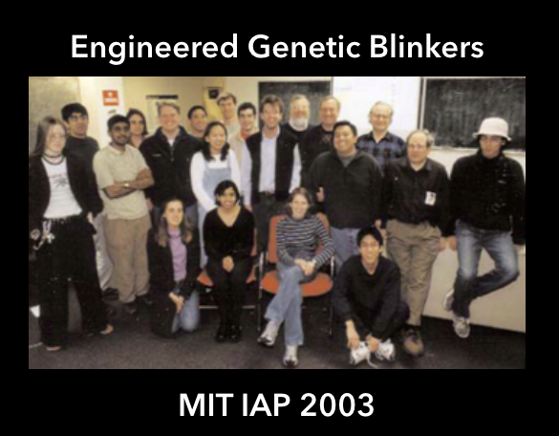
In November 2003, a small poster appeared around the MIT campus with the cryptic tagline: "Tired of evolving? Make new friends!” It was an advertisement for a four-week course during MIT’s Independent Activity Period (IAP). The IAP is a tradition started in1971 where, for four weeks in January, students can, “set their own educational agendas, pursue independent projects, meet with faculty, or pursue many other options not possible during the semester.” No grades, no failure, have fun, learn something new. The course, with the formal name: Synthetic Biology Lab: Engineered Genetic Blinkers was billed as a, “Hands-on introduction to the design and fabrication of synthetic biological systems. Students will work together in small teams to specify and design engineered genetic networks that program cells to periodically emit light.”

Sixteen students showed up. Here they are in a dated and blurred image. The woman sitting in the front row, middle left, is Reshma Shetty, now the President of Gingko Bioworks. Interestingly, three of the four people offering this course were not official MIT faculty and no one was an academically trained biologist. One instructor was Tom Knight, the instigator of the 1996 DARPA study.

Maybe synthetic biology was a contagious idea, but making it go viral was not easy. One challenge was convincing early entrants to the emerging field that they were not going down a dead-end career path with no future, no recognition, no pay check, and importantly, no intellectual community. Small, inexpensive activities played large, outsized roles. Every Wednesday, MIT’s Synthetic Biology Working Group would meet for lunch, normally burritos and soft drinks, to provide psychic and caloric nourishment to the nascent community. As Drew Endy would later emphasize, “We needed to create a cultural frame to operate…that is was ok to practice research in this area.”

By providing infrastructure, networking, and some minimal funding, MIT played a critical role in validation and community-building, in creating a niche (physically and intellectually) to support early innovation. It also provided titles and positions to people who did not easily fit into the academic hierarchy or established departmental organizational lines (early on, there was no bio-engineering department, for instance). The existence of ‘champions’ for the nascent field of synthetic biology was crucial and research on innovation has shown that, “champions tend to emerge in supportive environments, in which internal and external barriers are relatively low.”

In 2004, an effort was made to expand the nascent synthetic biology community across academic and geographic boundaries through the organization of a conference called Synthetic Biology 1.0 (or SB 1.0 for short) held at MIT and supported jointly by MIT's Biology Department, Biological Engineering Division, Electrical Engineering & Computer Science Department, Computer Science & Artificial Intelligence Laboratory, and MIT Synthetic Biology Working Group. An important goal of this meeting was to “place this scientific and engineering research within its current and future social context.” SB 1.0 was the first of what became 6 workshops held over the next decade that expanded to include meetings in Switzerland, Hong Kong and the UK.

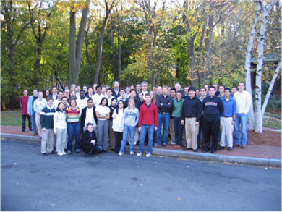
The next validator would be a Senior Advisor in the Computer and Networking Division of National Science Foundation, Frederica Darema, who had attended the 1996 DARPA summer session. Darema saw what was happening at MIT and provided $200,000 to expand the IAP course into a competition (she was adamant about the need for a competition, not a meeting) involving five universities the following year from MIT, Princeton, CalTech, University of Texas at Austin and Boston University. Not everything worked as planned (though one team developed an idea for bacterial photography) but it became obvious that having an expanding library of standardized parts could accelerate the design-build process, and help engage students who had grown up playing with parts-based construction tools and toys (from Legos to today’s video game: Minecraft).

This meeting was the genesis of the International Genetically Engineered Machines competition (iGEM) which has outgrown its venues multiple times and now barely fits into the Hynes Convention Center in Boston for a 4-day giant jamboree that is the culmination of the year-long competition. iGEM now engages over 5,000 students annually, 300 teams, 150 judges, and over 40 countries from 6 continents.

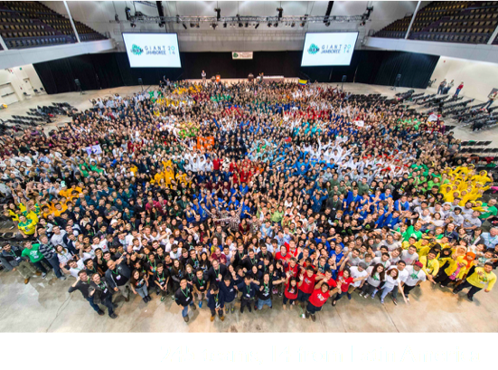
Randy Rettberg, today the head of the iGEM foundation and one of those who offered the IAP course in 2003, said that, “Our goal was to kickstart a billion dollar industry.” Looking back, iGEM has played a unique role in training the next generation of synthetic biologists for positions in industry and academia and creating a global, shared sense of community around an emerging field.

By 2004 it was becoming more apparent that the advances outlined by the scientists would not occur without major research investments and in 2005 a small group of researchers from MIT and the University of California/Berkeley approached the National Science Foundation. In 2006, NSF provided a $37.4 million, ten-year grant to a consortium of universities including MIT, Harvard, Stanford, and UC/Berkeley, under the leadership of Jay Keasling, a chemical engineer at Berkeley. The funding model used by NSF was for engineering, not biology — the creation of an engineering research center SynBERC (Synthetic Biology Engineering Research Center). The ERC program was established at NSF in April 1984 with the goal of developing fundamental knowledge in engineering fields that will enhance international competitiveness of U.S. industry and prepare engineers to contribute through better engineering practice.

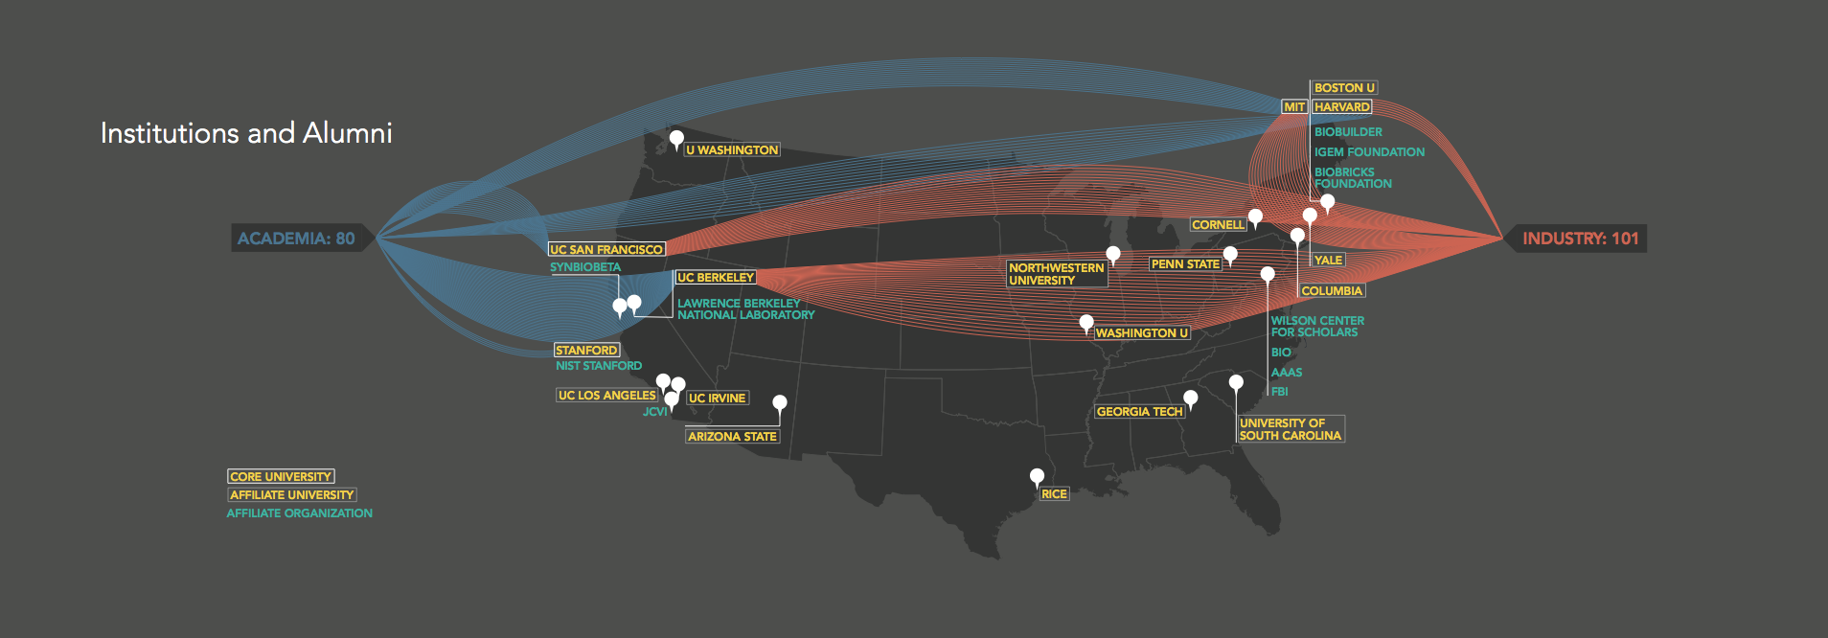
The grant specifically supported community building by requiring bi-annual meetings that alternated between Boston and San Francisco, creating an expanding community of practitioners from various universities, disciplines, and geographic areas, and also including industry representation through an external Industry Advisory Board (IAB). By the time the project ended in 2016, the activities had stitched together a massive network - a growing community with a common language and similar goals that now included people in the policy making and funding worlds as well as industry and extended outside of the US boundaries.
Looking back, Tom Knight noted that, “You cannot create a technology alone. You need buy-in on the part of thousands of people and you need redundant academic programs and efforts in the industrial sector. The most important thing we did was community building; creating an excited group of student who understood the sector.”
Using a much smaller $1 million NSF grant, a follow-on project, the Engineering Biology Research Consortium, has been recently launched to bring “…together an inclusive community committed to advancing biological engineering to address national and global needs.”
So What’s New?

Many researchers and scientists involved with synthetic biology spend a significant amount of time, and associated frustration, explaining why synthetic biology is not like the genetic engineering of the past. If one drills down on this distinction, two things appear repeatedly as differentiators: improvements in design-build-test-learn cycle and the use of standardized parts.

From an engineering perspective neither concept should be surprising. For instance, the development of standardized screws enabled precision scientific measurement and screw-controlled production machines between the 17th and 19th centuries — but these concepts are not a normal part of discourse in biology. Both concepts are connected: having reusable parts with defined and stabile performance characteristics enables faster and cheaper design, test, and build cycles.

Jack Newman, a co-founder of Amyris, told me that “…the DBT cycle was transformational, allowing the operational translation of fundamental science into stuff.” Richard Murray from Caltech, who co-chaired the 2003 DARPA sessions on synthetic biology, observed that the, “notion that we could design and build and get things to work was new, people started to talk design, rather than just trying to understand.” In 2011, when people at DARPA were looking for a rationale for their new Biology Technology Office, the idea arose: Why not focus on the DBT cycle? Tools that speed up the design cycle are critical and could provide a way to quantify progress in the field. These concepts of the DBT cycle and standardized parts played important roles as ‘boundary objects’ in the early phase of ecosystem creation, where the innovation ecosystem was still in the design phase, boundaries were fluid, and there was a need to go from ideas to tools, adoption, and measurable performance improvements both internal to and across organizations.

Design-Build-Test (and Learn)

“Manufacturing technology is, in essence, the technology of process control [it involves] the evolution of manufacturing from an art to a science.”

If the field of synthetic biology has been influenced by information metaphors, it has also embraced (or co-opted) a key concept that is familiar to most engineers and to more traditional manufacturing sectors such as aeronautics and electronics — the design-build-test cycle (DBT). Making things faster has been lauded as the single most important determinant of manufacturing productivity and was historically been a critical focus of companies such as IBM (Continuous Flow Manufacturing), Motorola (Short Cycle Management) and Westinghouse (Operating Profit through Time and Investment Management).

But biotechnology has been more art than science and has been consistently challenged by reproducibility issues — an engineered microbe might stop producing or the production rate could fluctuate. Scaling production from micrograms to kilograms and potentially to kilotons was an expensive, high risk, and costly process, often out of reach of small startups with limited capital and impatient investors. Biological systems resist control, which has necessitated the adaption of an approach with analogies to chemical synthesis. “The design strategy can be likened to building millions of variants of a chemical factory, selecting or screening for control system variant that yield the most product, and discarding all but one or two of the most productive designs.” Predictive modeling and computer-aided design tools common in other engineering disciplines are almost non-existent in biology.

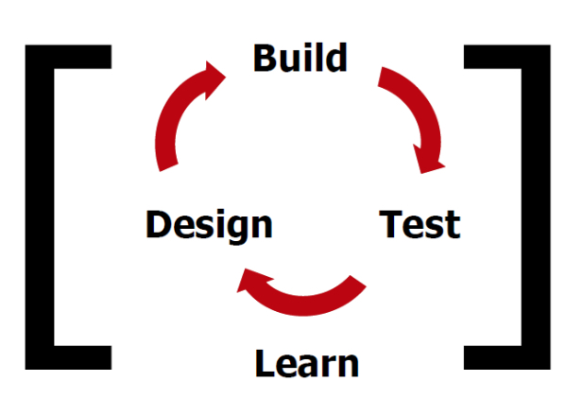
Against that background, many early researchers noted that, “Decreasing the design-build-test cycle length is a fundamental challenge facing all engineering disciplines. This is acutely true in synthetic biology.” The design-build-test cycle is the “fundamental building block of effective and efficient problem solving.” The ability to consistently shorten the DBT cycle can reduce lead times for product development and translate to competitive advantage, especially for those firms who enter markets early with superior product and can command premium prices.
Alicia Jackson, the Former Deputy Director of DARPA’s Biology Technologies Office noted that one of the most important things that DARPA did was to support the creation of tools to speed up the DBTL cycle (DARPA graphic shown). The focus on engineering the DBT cycle was not necessarily embraced by biologists. As one interviewee commented, “… biologists saw their contribution as insight, not testing. [They] got rewarded on publishing insight.”

Gaining greater control of the DBT cycle in synthetic biology requires the development of tools that allow mathematical modeling of metabolism, quantitative measurement and modeling of cellular dynamics and networks, precision gene editing, genome compiling, and phenotypic characterization — all of which support faster, more efficient creation of biological production platforms, There have now been a number of attempts to create computer-aided design tools and ‘apps’ for synthetic biology to, for instance, speed up the design of metabolic pathways or allow easier sharing of biological designs among labs. However, the field is still far from having a comprehensive suite of predictive, interoperable, and standardized models. One researcher commented that “it is not just building more tools, but building them in the right format.” One interesting initiative is the Department of Energy’s Systems Knowledge Base (KBase), which is an open platform for integrating analysis tools for functional genomics and systems biology. Adam Arkin noted that, “Open source and open access are the keys to reproducible science.” In some sense, the focus on the DBT cycle was an aspirational goal and is still far from realization. As Christina Smolke at Stanford remarked, it is part of the “…drive to improve cost, speed and accuracy and position biology as a precision manufacturing platform.”
Reusable, Standardized Parts

In 1813, Connecticut gun producer Simeon North signed a contract with the government to produce 20,000 pistols such that “the component parts of the pistols are to correspond so exactly that any limb or part of one pistol may be fitted to any other pistol of the twenty thousand.” North is credited with inventing the milling machine, which, along with more accurate measurement tools, made interchangeable parts and mass production possible.
Looking back, it is difficult to imagine early advances in mechanized production or the later IT revolution without standardized parts with reproducible characteristics — from screws to resistors — combined with increasingly accurate measurement tools. It is not just that these parts accelerated the assembly of complex products, historically, standardization has been linked to innovation, improved in-company R&D efforts, increased length and complexity of supply chains, better quality management, and greater network effects. Recognizing the pervasive impacts of standardization and measurement, most countries have dedicated organizations devoted to this task (so-called National Measurement Institutes or NMIs) and important economic sectors support global efforts to insure interoperability and enable open innovation platforms.

Given the engineering antecedents of synthetic biology, it is not surprising that researchers recognized the potential offered by standardization. An early effort of this type was BIOFAB, created in 2009, which placed over 2,500 standardized, quantitatively defined, biological parts in the public domain. The Registry of Standard Biological Parts was established at MIT as part of the international Genetically Engineered Machine (iGEM) competition, an undergraduate synthetic biology research competition started in 2004, which now typically includes over 250 teams globally.. One key feature of this initiative was to link the parts registry to the IGEM competition so each year’s teams benefit from past efforts and can use, improve, and create new parts, growing the registry to its existing size of over 25,000 biological parts.

These registries drove increasing interest in open-source protocols and legal frameworks to support the sharing and use of standardized parts, such as the BioBricks Foundation.
The Open Plant project in the UK is designed specifically to support open-source sharing of plant-related parts and constructs. In the end, the architecture of the system should support collaboration and allow scaling of design beyond individuals and individuals groups and support collaborative design and production strategies which we have seen in other industries. For instance, Adobe abandoned early strategies to form a standalone product and instead focused on allowing its PostScript typeface system to be easily integrated into other platforms that brought the technology to consumers.

As sequencing technologies advance, physical parts become less critical, since they an be created from code. However, what does not change is the need for accurate documentation for the parts, including description and performance characteristics, combined with incentives to make parts better with the large goal of driving out defects in the field. As libraries of parts expand, the search space for innovative combination grows and researchers can stitch together large genetic constructs, moving from pathway design to whole organisms. The open source ethos was a radical departure from the way biotech had been historically organized and it creates a new way of shaping production methods, both inter and intra-firm.

Underlying both these changes was a ongoing shift towards digitalization of genetic information. In 2013, a letter by Francis Crick, the co-discover of the DNA helix, was auctioned off for $6 million. In this letter to his son, Crick makes the following observation: “Now we believe that the DNA is a code. That is, the order of the bases (the letters) makes one gene different from another gene (just as one page of print is different from another).” As Matthew Cobb noted in a recent history of the genetic revolution, “…the information sciences provided biologists with loose but useful metaphors and analogies, a language that allowed scientists to think and speak in new ways.”

Decades later, information metaphors provided a conceptual scaffold to the ideas emerging from synthetic biology regarding mathematical abstraction, decoupling design from fabrication, open source sharing, and the reading, writing, and editing of genes. As Craig Venter famously described the synthetic organism they developed in 2010: “the father was a computer.”

Nan Li from Obvious Ventures in San Francisco California has stated that synthetic biology is going through “a digitalization and automation”. Drew Endy from Stanford University has described the goal of synthetic biology as “making living matter fully programmable.” A recent workshop at MIT made this analogy between the world of computing and the world of biology:
“Just as analog/digital and digital/analog converters provide the interface between computers and the physical world of sensors and actuators, "biology/digital" and "digital/biology" converters are allowing computers to create and control biological worlds.”

Today, many synthetic biology startups describe themselves as “computer science companies” and build data structure libraries to explore the genomic space of organisms. Patrick Westfall of Zymergen stated that, “We are a software company.” DJ Kleinbaum, the co-founder of Emerald Therapeutics, a startup building cloud labs, noted that, “we train every scientist we hire to write code.” When biology becomes a computer science field then it lends itself to reusable code, agile development practices that originated in the computer industry, system architectures that can support greater collaboration, reproducible science, and the creation of new market niches through disaggregation.

Value Chain Disaggregation

“The corporate boundaries that matter today are the boundaries that define and contain the corporation’s innovation search(es).”

One the most consequential impacts of applying an engineering paradigm to biology is the disaggregation of the historical value chains that have dominated medical and agricultural biotech, where investments required for large-scale production, marketing, and distribution often required 70-80 percent of the product-related budget. Firms are now entering the market with promising new business models and this is happening at a time when large, first-wave biotech firms are tending towards consolidation, bordering on monopolistic aggregation, such as the the awaited, and disputed, Dow and Dupont merger, which may eventually occur in the first quarter of 2017, and the possible merger of BASF, Monsanto and Bayer. In addition, second-wave biotech firms, which focused largely on biofuels, often failed to scale and were undermined by the price volatility of commodity markets.

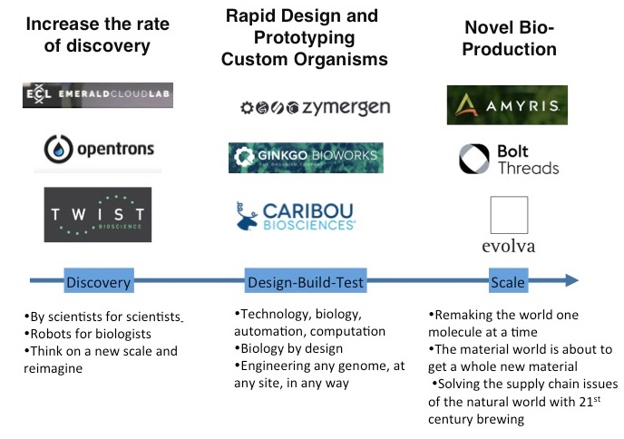
New synthetic biology firms are not burdened by legacy supply chains and entrants are organizing around emerging capabilities such as rapid design and prototyping, agile development, customized assembly, novel production, and techniques that generally increase the rate of discovery at lower cost. As one CEO told me, “this is not about rethinking the existing business model, but displacing it.” This disaggregation reflects a more pervasive trend in business where firms are ‘splintering’ supply chains as an approach to build long-term resilience and a hedge against uncertainty arising from demand and price volatility, shifts in consumer preference, and currency fluctuations. What some term de-verticalization is creating viable business niches for synthetic biology firms in areas that have traditionally been categorized as turn-key and component suppliers in normal value chains. Disaggregation has also reduced the capital demands that have been traditionally associated with biotechnology and opened up an alternative path for those interested in biology who historically have gone to universities or large industries. The graphic below shows a rough mapping of the disaggregated value chain with some example companies and associated slogans that capture their value propositions.
There are productive links already forming across the value chain. For instance, Twist Biosciences is supplying at least 400 million base pairs of DNA to Gingko Bioworks, which in turn develops custom engineered organisms for other industries. This strategy allows new entrants to better manage the risks and investments of large-scale production, marketing, and distribution, long associated with mature medical biotech, pharma and ag biotech firms. The goal is not to build whole new production pipelines, but to fit into emerging or existing ones. Other business niches have emerged with a direct focus on speeding up the experimental processes itself using cloud-based labs, automation, machine learning, and robotics. Firms I interviewed stressed the value in having lots of experiments available and being able to dramatically reduce time/cost per experiment. Historically, there was little or no scaling factor in genetic engineering. If you wanted to do twice as much engineering, you hired twice as many scientists and post-docs. Now, the design of new organisms is no longer subject to fixed scale economics.

To succeed in the long term, a disaggregation strategy requires collaboration and a high level of information sharing across organizational boundaries, an approach that supported agile development practices in the software industry. For instance, Adobe abandoned early strategies to form a standalone product and instead focused on allowing its PostScript typeface system to be easily integrated into other platforms that brought the technology to consumers. Synthetic biology firms have adapted a similar strategy: engineering microbes that do not require customers to change their existing manufacturing processes - just plug and play. One firm emphasized that “If they [our customers] are using 100,000 liter fermenters, then our strain needs to work in these.” Another CEO told me that they work to “bring our customer demands back to the biologists.”

Viewed from a historical perspective, we are seeing the application of learning-by-doing-faster and learning-before-doing strategies to biological production, for instance, by using predictive algorithms or machine learning to reduce process development times and close the gap between actual and potential performance in existing production systems. Some firms, such as Zymergen, allow the learning to be taken off-line, optimized, and re-integrated into existing processes of other firms, while others use this capacity as an integral part of their R&D efforts and technology stack.

Firms are also adapting open source strategies for robotic systems, such as OpenTrons, which allows users of its robotic pipetting device to share their programs with others (writing protocols is facilitated through a shared API). As scholars have pointed out, “open source is a way of organizing production, of making things jointly.” The result is an innovation and production platform rather than just a collection of discrete firms. Sharing also provides advantages in assessing and forecasting user/customer demand. This strategy reflects the thinking behind the lean startup movement with its emphasis on fast hypothesis testing, with agile product development in short cycles informed by feedback from users and customers.

New Economic Space

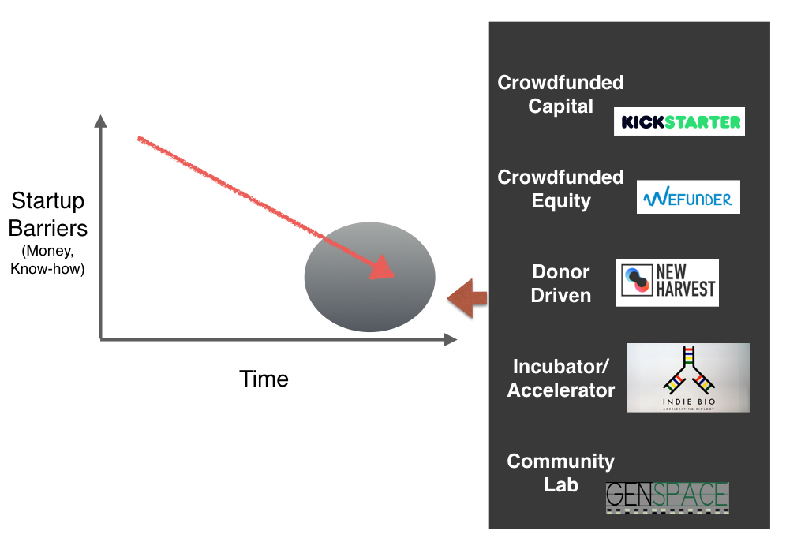
Open source software like GitHub combined with cloud services like Amazon Web Services have driven the cost of software development from millions of dollars to thousands. Hardware developers now have new low-cost options available such as 3-D printing for prototyping and low-volume production, or can move to offshore manufacturing for high volume runs. The efficient out-sourcing of infrastructure, from computation to experimentation, has dropped the investment costs for startups by orders of magnitudes over the past decade.

Reduced start-up costs are colliding with increasing options for funding, ranging from crowdfunding to donor-based models and accelerators (see graphic below). In addition, the proliferation of community labs have given increasing numbers of potential entrepreneurs access to tools and basic know-how at low cost. There has been increased discussion about the so-called ‘democratization of biotechnology,’ making biology accessible to a wide range of individuals outside of formal academic settings.

Crowdfunding: Numbers from a 2015 study indicate that individuals invested a collective $34 billion in crowdfunding projects across 1,250 on-line platforms worldwide, marking over a 100% increase from 2014, and a 1000% increase from the crowdfunding industry’s value in 2009. Projections from the World Bank and other sources indicate that global crowdfunding could reach $90 billion sometime between 2020 and 2025, exceeding more traditional forms of financing like venture capital and angel investors (now investing an average of $45 billion and $20 billion per year, respectively). In October 2015, the US Securities and Exchange Commission adapted a new rule that allows companies to offer and sell securities through crowdfunding. Title III of the USA JOBS Act created an exemption so that this type of funding method can now be used. As a result, backers receive profits if the project succeeds.
Donor-based: Another model is represented by the non-profit New Harvest which is supported by over 400 individual donors contributing almost $1,000,000, with donations ranging from $1 per month to $100,000 per year. Funding supports critical, pre-competitive research needed to move towards successful, large-scale cellular agriculture that is crucial to replace animals with cell cultures for protein production.
Accelerators: Today, there are over 160 accelerators in the United States, one of the most notable being Y Combinator. IndieBio (short for Independent Biology) is the world’s first synthetic biology accelerator, offering capital and mentoring for startups during a 16 weeks on-site competitive program. Beside providing laboratory space for entrepreneurs in San Francisco, IndieBio provides $250,000 ($50,000 in direct funding, $50,000 in equity investments and a $150,000 convertible note), mentoring, and an opportunity to pitch your idea and business plan to venture capital funders and angel investors during a DemoDay. Early experiences at spaces like this has showed that innovations can move from idea to product in months rather than years.

Community Labs: Finally, community bio labs have become incubators for startups (some people label them ‘pre-incubators’, which may be more accurate). The most notable examples in the US are GenSpace (New York City’s Community Biolab), Biocurious in Silicon Valley, and BUGGS (Baltimore Underground Science Space). Most of these community labs have an explicit focus on outreach and education providing an informal route for people to engage in biology at low cost through courses, access to laboratory equipment, and interactions with others. The largest biohacking and open science space in Europe is La Paillasse (‘the bench’), in Paris, which has an explicit goal of improving entrepreneurship in France.

These funding options are not mutually exclusive. The story of OpenTrons (see box) illustrates how an idea which came from a community lab moved to crowdfunding and then onto an accelerator.

_____________________________________

BOX: Pipetting Got You Down?

In 2014, Will Canine, a 24-year old with a background in political campaign management wandered into the Brooklyn community bio lab GenSpace to take part in their BioHacker Boot Camp. Struggling to remember his high school biology AP course, Canine quickly tired of pipetting and found a solution on the DIYbio list serve, a robotic pipetter developed by Chiu Chau, a mechanical engineer and biotech industry veteran who had ingeniously programed a 3-D printer to pipette.

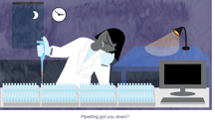
Chau and Canine put the robot on Kickstarter in 2014 as Opentrons: Open-Source Rapid Prototyping for Biology, hoping to raise $100,000. 237 backers pledged $126,694 to help bring the project to life. People who pledged a minimum of $2,000 received the first robots (they now have 3 models, ranging from $3,000 to $4,000). It’s open source, so users that build apps can share them on the Opentrons website.

Chau and Canine estimated that on any given day, there were around 4 million unhappy grad students, post-docs, and lab assistants pipetting who would rather be doing science, so the market is potentially large. As Canine explained to one reporter: "'Basically, if you’re a biologist you spend all of your time moving tiny amounts of liquid around from vial to vial by hand with a little micro-pipette or you have a $100,000 robot that does it for you. We’re a $3,000 robot.”

By the end of 2015, Opentrons had 50 of their pipetting robots in 28 countries, including labs at MIT, Stanford and CalTech and hospitals like Sloan Kettering. The company participated in the Winter 2016 class of the tech accelerator Y Combinator. Sales hit 180 in 2016 and hopefully will reach over 500 this year.

________________________________________________________________________

The Geographic Space

“Technology transfer is the movement of ideas in people.” –Donald Kennedy, Stanford University, March 18, 1994

The idea that certain types of economic activities tend to cluster geographically has a long history in economics and geography, going back to at least to the work of the British economist Alfred Marshall. As some recent research has pointed out, “What matters today isn’t where most people settle, but where the greatest number of the most skilled people does.” The clustering of high-value synthetic biology firms is concentrated around San Francisco and Boston, both areas where significant government and private-sector investments in the field occurred over the last decade at universities like MIT, Harvard and Boston university as well as Stanford and the University of California/Berkeley. As one CEO told me, “We need talent and dollars.”

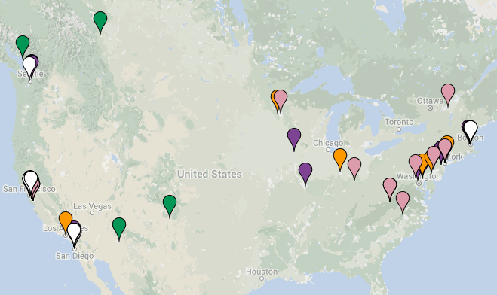
Proximity matters. A number of interviewees emphasized the importance of the spatial proximity needed to drive innovation, where microbiologists can interact regularly with computer programmers, robotics experts, process engineers, and marketing experts, There is unlikely to be significant knowledge spill overs as distance increases, which puts a premium on co-locating staff and maintaining close ties to universities training next generation talent.

In 2010, San Francisco overtook Silicon Valley in terms of gross venture capital investment and recent research has shown the around 40 percent of the ‘unicorns’, firms that have achieved at least $1 billion of valuation, are located within the municipal boundaries of the city versus 23 percent in Silicon Valley. The city has created what some have termed a ‘reflexive start-up economy’ which facilitates new business formation through a combination of tax incentives, mentoring programs, and political support mechanisms for the tech sector (such as a Tech Chamber of Commerce). As the new disruptors have moved north from Silicon Valley, it remains to be seen where the fertile ground for the biology disruptors will take hold.
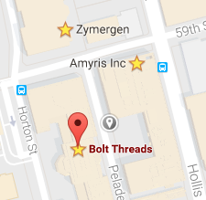
An interesting cluster has grown across San Francisco Bay in Emeryville where Amyris, Zymergen, and Bolt Threads exist within a few blocks from each other (and close to Pixar Studios). Like Pixar, these biotech firms have a growing demand for computer programers and informatics experts. Globally, similar synthetic biology innovation clusters are appearing around Shanghai in China and in the Oxford-Cambridge-London triangle in the UK, driven by a combination of physical, economic, and networking assets that have driven the growth of similar clusters in the US.

Barriers

“if consumers don’t use it, there is no market”

There is an old adage in Silicon Valley that innovation requires a combination of “rich people”, “nerds” and “risk taking.” That may not be enough. There are some important ways in which synthetic biology differs from other innovation platforms and the most crucial are the regulatory and public perceptions barriers that may hinder the introduction of new products into the market. Manipulating biological organisms, or creating novel ones, can produce safety and security risks, while provoking public backlash that ultimately affects market emergence and growth.
CEOs, university researchers and government officials I spoke with worried about possible push back from the public and NGOs that could impact market development. In addition, companies operating in the US are face-to-face with an antiquated and opaque regulatory system, last updated in 1992, that is especially difficult to navigate for small firms. The regulatory barriers become more critical since the synthetic biology field is witnessing what one interviewee called the “operational translation of fundamental science into stuff” and it is the ‘stuff’ that we regulate. The challenge now is how to go to scale and to market.

Regulatory modernization efforts launched in July 2016 by the Obama White House are awaiting their fate in the new Trump administration. Both FDA and USDA released information on proposed rules on January 19, 2017, designed to clarify the regulations of genetically modified mosquitoes and address issues around gene editing in animals and plants.

Opaque and overly complex regulatory systems will likely push startups along three paths, design around the regulations by focusing on products with low or no regulatory hurdles, closely imitate products with existing regulatory approval, or partner with larger firms with experience and money to navigate the regulatory approval process.

A number of people interviewed pointed out that the drawn out regulatory processes exceeds the time that startups can stay afloat and viable. The genetically modified AquAdvantage salmon took two decades to get regulatory approval from the Food and Drug Administration (if took over 10 years for FDA to determine how to regulate the fish).

Researchers remain concerned about possible public divisions over the risks and benefits of synthetic biology. Public perception studies of synthetic biology in the United States indicate an accepting but cautious set of potential consumers with attitudes often tied to applications, concerns over unintended and long-term effects, and low trust in the federal government to manage the risks associated with the technologies (with declining trust in NGOs, scientists, and industry). Perceptions may change as more synthetic biology based products enter the marketplace. Millions of dollars in campaigns have failed to move the needle of public concern over GMOs in the US (though not Europe). The initial furor over nanotechnology risks (self-replicating bots, grey goo, super weapons, etc.) has largely declined over the past decade.

There remain worries about how synthetic biology is represented in the press, often over-hyped, with little nuanced coverage, and the impact this could have on demands for oversight. “The hype machine is out of whack,” said one researcher.

Lessons

“In a world where many players are all adapting to each other and where the emerging future is extremely hard to predict, what actions should one take?”

Today, more than 40 countries worldwide have some type of bioeconomy strategy and are promoting the bioeconomy as at least part of their science, technology, and economic policies. Global activities in this area provided the impetus for a 2015 Global Bioeconomy Summit in Berlin, which emphasized the need for more collaboration across national boarders in areas such as R&D, innovation, and the pursuit of global objectives focused on food security and sustainable development. Interestingly, the United States does not have an operable bioeconomy strategy. One was created and released in April 2012 but it disappeared in the political undercurrents of the 2012 Presidential election, never to surface again.
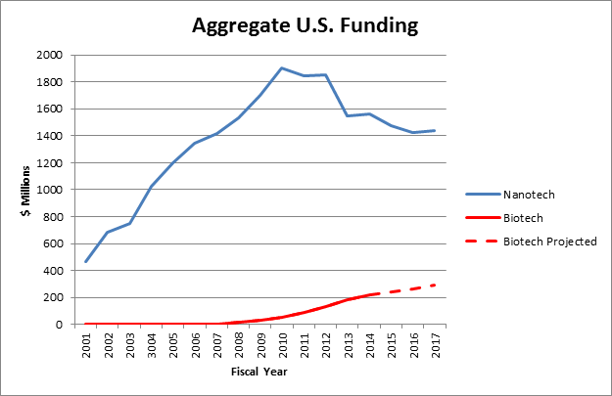
In terms of high level policy focus, government investments, and programmatic actives, the support of synthetic biology pales relative to other S&T initiatives such as the US National Nanotechnology Initiative (NNI) or Human Genome Project. Over the past decade, for instance, the US government has invested around $15 billion dollars in nanotechnology, setting up over two dozen nano-science and engineering centers. In contrast, synthetic biology has received less than $1 billion in federal funding and benefited from only one center, the Synthetic Biology Engineering Research Center, mentioned earlier. What both the nanotechnology and synthetic biology share, however, is an approach that can be characterized as bottoms-up with centralized coordination, a departure from highly centralized, top-down, government-driven projects with a focused goal, such as the Apollo Space Program. Charles Vest, the former President of the U.S. National Academy of Engineering, described the National Nanotechnolgy Initiative (NNI) as “…a new way to run an initiative.”

Viewed from this perspective, synthetic biology presents an intriguing case and raises the questions of whether lower cost, bottom up strategies in highly emergent systems can drive innovation without the need for large investments, top-down planning, and formal technology roadmaps. Put another way: Is what happened with synthetic biology in the United States an outlier, or a harbinger of what science and technology policy will look like in the future?

If this case is not an outlier, then the challenges it presents to public policy will be significant and the lessons worth learning. Finding the right leverage points and timing in dynamic innovation systems remains a challenge for most government policymakers. One of the critical implications of emergent systems for policymaking is that regularities and periods of stability will be visible in hindsight only. Winning strategies are likely to assume systems under constant development that are never fully specified and subject to constant adjustment and adaptation. As some researchers on complex systems have recently noted, [such systems] “…have a number of implications for thinking about policy…For one, such an effect makes forecasting difficult, if not impossible, as you can’t link cause and effect. For another it means that it will be very hard to backward engineer the system . . . ” In these systems Improvisational strategies may be the most effective, which depend on two capabilities: a free flow of information among actors and a few basic rules of interaction. Strategic flexibility will win over strategic plans.

The US presidential election of November 2016 may provide an unanticipated test and help answer the question of whether the innovation ecosystem created around synthetic biology over the last twenty years is robust enough to continue to flourish without top down interventions or in the face of counterproductive budgetary or regulatory interventions. This experiment is running now.

Interviews;

Companies:

Jason Kelly, Co-founder, Ginko Bioworks [http://www.ginkgobioworks.com/]

Patrick Westfall, Director, Business Development and Fundamental Science, Zymergen [http://www.zymergen.com/]

DJ Kleinbaum, Co-Founder, Emerald Therapeutics [http://emeraldcloudlab.com/]

Emily Leproust, Chief Executive Officer, Twist Biosciences [https://www.twistbioscience.com/]

Dan Widmaier, CEO and Co-founder, Bolt Threads [https://boltthreads.com/]

Rachel Haurwitz, President and CEO, Caribou Biosciences [http://cariboubio.com/]

Jack Newman, Co-founder, Zagaya, Chief Science Officer, Amyris [http://www.zagaya.org/about/team/]

Will Canine, Founder, OpenTrons [https://opentrons.com/]

Isha Dakar, CEO, New Harvest [http://www.new-harvest.org]

Academic Researchers:

Adam Arkin, Professor of Bioengineering, University of California, Berkeley [http://bioeng.berkeley.edu/faculty/adam_arkin]

Peter A. Carr, Senior Staff, Synthetic Biology Lead, MIT Lincoln Laboratory

Drew Endy, Associate Professor of Bioengineering, Stanford University [https://profiles.stanford.edu/drew-endy]

Jim Haseloff, Head, Department of Plant Sciences, University of Cambridge [http://data.plantsci.cam.ac.uk/Haseloff/]

Tom Knight, MIT; Board of Directors, BioBricks Foundation; Founder, Ginko Bioworks [https://www.fastcompany.com/3000760/tom-knight-godfather-synthetic-biology-how-learn-something-new]

Natalie Kuldell, President, The Biobuilder Foundation, MIT Department of Biological Engineering [http://educationgroup.mit.edu/HHMIEducationGroup/?page_id=2918]

Kris Prather, Associate Professor of Chemical Engineering, MIT [http://web.mit.edu/prathergroup/]

Richard Murray, Professor of Control and Dynamic Systems and Bioengineering, California Institute of Technology [http://www.cds.caltech.edu/~murray/wiki/Main_Page]

Christina Smolke, Associate Professor of Bioengineering, Stanford University [http://smolkelab.weebly.com/]

Pamela Silver, Professor of Systems Biology, Harvard Medical School [https://silver.med.harvard.edu/]

Jay Keasling, Professor or Chemical and Biomolecular Engineering and Bioengineering, University of California/Berkeley [http://chemistry.berkeley.edu/faculty/cbe/keasling]

Nathan Hillson, Director of Synthetic Biology Informatics, Joint Bioenergy Institute, Lawrence Berkeley National Lab [http://www.jbei.org/people/directors/nathan-hillson/]

Government

Theresa Good, Program Director Systems and Synthetic Biology, National Science Foundation [https://www.nsf.gov/mobile/staff/staff_bio.jsp?lan=tgood&org=MCB&from_org=]

Alicia Jackson, Former Deputy Director, Biology Technologies Office, DARPA (presently CTO, Drawbridge Health Inc.) [https://www.linkedin.com/in/alicia-jackson-6878834]

Marc Salit, Leader, Genome-Scale Measurements Group, National Institute of Standards and Technology, Material Measurement Lab and Joint Initiative for Metrology in Biology [http://www.nist.gov/mml/bbd/biomolecular/msalit_bio.cfm]

Other

Ellen Jorgensen, Founder and Director, GenSpace [http://genspace.org/]

Randy Rettberg, President, iGEM Foundation [http://igem.org/Main_Page]

John Cumbers, Founder, Synbiobeta [http://synbiobeta.com/]

Economist 2012. “The Third Industrial Revolution,” April 21.
Rauner, Max 2016. “Wenn ich mit euch fertig bin, seid ihr ein Joghurt,” Die Zeit, January 4.
OECD 2015. Enabling the Next Production Revolution: Issues Paper, Paris, OECD, March.
A more fruitful conceptual framework that could be applied to technological change is a ‘general purpose technology’ (GPT). Earlier GPTs have included such developments as the steam engine or electricity, which had multiple downstream and long-term impacts involving a wide range of sectors . See:? Helpman. E. & Trajtenerg, M. 1996. Diffusion of General Purpose Technologies, Cambridge, MA: National Bureau of Economic Research, Working Paper 5773.
Compare, for instance, Walter Gropius’s assertion in the 1930’s: “The Bauhaus accepts the machine as the most modern means of design.”
Arthur, Brian 2009. The Nature of Technology: What It is and How It Evolves, NY: Free Press.
Evans, Peter & Gawer, Annabelle 2016. The Rise of the Platform Economy: A Global Survey, Cambridge, UK: The Center for Global Enterprise.
Data from SynbioBeta: The Activity Hub for the Synthetic Biology Industry, http://synbiobeta.com/
Hayden, Erika 2015. “Tech Investors Bet on Synthetic Biology,” Nature, November 5, Vol. 527, p. 19.
Buhr, Sarah 2016. “Ginkgo Bioworks Grabs $100 Million in Financing to Purchase a Whole Lot of Synthetic DNA,” TechCrunch, June 8. https://techcrunch.com/2016/06/08/ginkgo-bioworks-grabs-100-million-in-financing-to-buy-a-whole-lot-of-synthetic-dna/
de la Merced, Michael 2016. “Zymergen Raises $130 Million in New Round of Financing,” New York Times, October 11.
Johnson, Steven 2014. How We Got to Now, NY: Penguin Books.
Truex, D.; Baskerville, R. & Klein, H. 1999. “Growing Systems in Emergent Organizations.” Communications of the ACH, Vol. 42, No. 8, pp. 117-123.
Szybalski, Wacław 1974. “In Vivo and in Vitro Initiation of Transcription,” Page 405. In: A. Kohn and A. Shatkay (Eds.), Control of Gene Expression, pp. 23–4, and Discussion pp. 404–5 (Szybalski's concept of Synthetic Biology), 411–2, 415–7. New York: Plenum Press.
Special thanks to Tom Knight for sharing his slides from the 1996 meeting.
See: Collins, J. & Porras, J. 1996. “Building Your Company’s Vision, Harvard Business Review, Vol. 74, No. 5, pp. 65-77.
Knight, T. et al. 2002. Idempotent Vector Design for the Standard Assembly of Biobricks.
The original DARPA briefing: Endy et al., 2003 DARPA ISAT Synthetic Biology Study, doi:1721.1/38455. An overview of the work: Endy, Drew 2005. “Foundations for Engineering Biology.” Nature, Vol. 438/24, PP. 449-453.
For an overview of the TIA program’s problems see: Kessler, Matt 2015. “The Logo That Took Down a DARPA Surveillance Project,” The Atlantic, December 22.
For an overview of trading zones, see: Gorman, M.2010. Trading Zones and Interactional Expertise: Creating New Kinds of Collaboration, Cambridge, MA: MIT Press.
Piore, Michael 2007. “A Critical View of Schumpeter’s ‘Theory’ of Innovation,” Presentation at the Conference on Capitalism and Entrepreneurship, Cornell University, September 28.
Shaw, Thomas 1944. “The Conquest of Distance by Wire Telephony,” Bell System Technical Journal, Vol. 23, October, pp. 337-441.
http://web.mit.edu/iap/about/index.html
Course description is at: http://web.mit.edu/iap/www/iap03/searchiap/iap-4968.html
I am indebted to Drew Endy, who searched his archives for material from this era.
Peters, Lois et al. 2004. “The Role of Incubators in the Entrepreneurial Process,” Journal of Technology Transfer, January, Vol 29, Issue 1, pp. 83-91.
Lichtenthaler, U. & Ernst, H. 2009. “The Role of Champions in the External Commercialization of Knowledge,” Journal of Product Innovation Management, Vol. 31, No. 3, pp. 636-637.
http://syntheticbiology.org/Synthetic_Biology_1.0.html
SB 7.0 will take place June 13 -15, 2017 in Singapore. See: http://sb7.info/
GAO 1988. Engineering Research Centers: NSF Program Management and Industry Sponsorship, Washington, DC: Government Accountability Office, Report GAO/RCED 88-177.
Graphic used courtesy of Karen Ingram.
https://www.ebrc.org/
The impact of the screw is often forgotten, but well explained in: Brooks, Randall 1992. “Towards the Perfect Screw Thread: The Making of Precision Screws in the 17th - 19th Centuries,” Transactions of the Newcomen Society, January, Vol. 64, No. 1, pp. 101-119.
Carlile, Paul 2002. “A Pragmatic View of Knowledge and Boundaries: Boundary Objects in New Product Development,” Organization Science, Vol. 13, No. 4, July-August, pp. 442-455.
Jaikumar, Ramchandran (2005). “From Filing and Fitting to Flexible Manufacturing: A Study in the Evolution of Process Control,” Technology, Information and Operations Management, Vol. 1, No. 1.
Schmenner, Roger 1988. “The Merit of Making Things Faster,” Sloan Management Review, Fall.
Paddon, Chris & Keasling, J 2014. “Semi-synthetic Artemisinin: A Model for the Use of Synthetic Biology in Pharmaceutical Development,” Nature Reviews Microbiology, Vol. 12, pp. 355-367.
Sunn, Z.Z.; Notreaux, V.; Murray, R. M. 2014. “TX-TL Cell-free Systems, Linear DNA, and Modular Assembly,”
Wheelwright, S. & Clark, K. 1994. “Accelerating the Design-build-test Cycle for Effective Product Development,” International Marketing Review, Vol. 11, No. 1.
Nielsen, Jens 2016. “Advancing the Design-Build-Test Cycle for Metabolic Engineering of Yeast,” American Institute of Chemical Engineers, Webinar, Feb, 24.
See the Autodesk application platform for synthetic biology, Clotho. https://www.autodeskresearch.com/projects/clotho
See: https://kbase.us/
The US National Institute of Standards and Technology (NIST) has recently opened a satellite office at Stanford University, the Joint Initiative for Metrology in Biology, see: http://news.stanford.edu/press-releases/2016/05/20/stanford-nist-coring-tiny-things/
http://partsregistry.org and http://www.igem.org
http://bbf.openwetware.org
Chesbrough, Henry 2003.”Open Platform Innovation: Creating Value from Internal and External Innovation,” Intel Technology Journal, August 19, Vol. 7, Issue 3.
Cobb, Matthew 2015. Life’s Greatest Secret: The Race to Crack the Genetic Code, NY: Basic Books.
Quoted in: U.S. Department of Defense 2015. Technical Assessment: Synthetic Biology, DoD Office of Technical Intelligence, Office of the Assistant Secretary of Defense for Research & Engineering.
MIT Center for Bits and Atoms 2014. Workshop Description, May 1.
Personal communication 3/18/2015.
Personal communication, 3/17/2015
Muller, A. & Vaelikengas, L. 2002. “Extending the Boundary of Corporate Innovation,” Strategy and Leadership, Vol. 30, No. 3, pp. 4-9.
Bunge, Jacob 2016. Dupont, Dow Chemical Merger Seen Closing in Q1, Market Watch, October 25.
Malik, Y., Niemeyer, A.. & Ruwadi, B. 2011. “Building the Supply Chain of the Future, McKinsey Quarterly, January.
Sturgeon, Timothy 2001. “How To Define Value Chains and Production Networks,” IDS Bulletin, Vol. 32, No. 3.
Shigeta, Ron 2016. “The New Economics of Biotech Offers a Third Way for Scientists,” https://sosv.com/the-new-economics-of-biotech/
Personnel communication. Jason Kelly, February 3, 2016.
Chesbrough, Henry 2003.”Open Platform Innovation: Creating Value from Internal and External Innovation,” Intel Technology Journal, August 19, Vol. 7, Issue 3.
Pisano, Gary 1994. “Knowledge, Integration, and the Locus of Learning: An Empirical Analysis of Process Development,” Strategic Management Journal, Vol. 13, pp. 85-100.
Weber, Steven 2004. The Success of Open Source, Cambridge, MA: Harvard University Press.
Gawer, A. & Cusumano, M. Platform Leadership: How Intel, Microsoft, and Cisco Drive Industry Innovation,
Blank, Steve 2013. “Why the Lean Start-Up Changes Everything,” Harvard Business Review, May.
See: Massolution. Crowdsourcing.org: The Industry Website. Rep. Massolution.com, 31 Mar. 2015. Web. 09 Aug. 2016 and Luzar, Charles. "Fundable: Crowdfunding Will Add 270,000 Jobs in 2014."Crowdfund Insider. N.p., 7 Jan. 2014. Web. 22 July 2016.
Barnett, Chance. "Trends Show Crowdfunding to Surpass VC in 2016."Forbes, 9 June 2015. Web. 09 Aug. 2016.
“SEC Adopts Rules to Allow Crowdfunding,” Washington, DC: US Securities and Exchange Commission, October 30, 2015. https://www.sec.gov/news/pressrelease/2015-249.html
www.new-harvest.org
Information at: http://sf.indiebio.co/about/
Shigeta,Ron 2016. “The New Economics of Biotech Offers a third Way for Scientists,” February 27, https://sosv.com/the-new-economics-of-biotech/#
http://genspace.org/, http://biocurious.org/, and http://www.bugssonline.org/
http://lapaillasse.org/services/
http://genspace.org/event/20150706/1800/Biohacker%20Boot%20Camp
http://docs.opentrons.com/?_ga=1.95892958.397602213.1483995059
Buhr, S. 2016. “Opentrons Aims to be the ‘PC’ of Biotech Labs,” TechCrunch, Feb. 1.
Marshall, A. 1890. Principles of Economics, NY: Macmillan.
Florida, Richard 2006. “Where the Brains Are,” The Atlantic Monthly, October.
McNeill, Donald 2016. “Governing A City of Unicorns: Technology Capital and the Urban Politics of San Francisco,” Urban Geography, Vol. 37, No. 4, pp. 494-513.
Thrift, Nigel 2005. Knowing Capitalism, London: Sage.
Katz, Bruce & Wagner, July 2014. The Rise of Innovation Districts: A New Geography of Innovation in America, Washington, DC: Brookings Institution.
Personal communication. Rachel Haurwitz, President and CEO, Caribou Biosciences
A formula attributed to Paul Graham, the founder of the Silicon Valley innovation accelerator Y Combinator.
See: FDA genome editing in animals: https://s3.amazonaws.com/public-inspection.federalregister.gov/2017-00839.pdf, and regulation of mosquitos products: https://s3.amazonaws.com/public-inspection.federalregister.gov/2017-00838.pdf
Hart Research 2013. Awareness and Impressions of Synthetic Biology: A Report of the Findings, Washington, DC. Synthetic Biology Project, Woodrow Wilson Center, http://www.synbioproject.org/publications/6655/
Kahan, Dan 2017. “One the Sources of Ordinary Science Knowledge and Extraordinary Science Ignorance,” in: Oxford Handbook of the Science of Science Communication, Oxford, UK: Oxford University Press.
Alexrod, Robert & Cohen, Michael 1999. Harnessing Complexity: Organizational Implications of A Scientific Frontier, NY: Free Press.
El-Chichakli, Beate et. al. 2016. “Five Cornerstones of a Global Bioeconomy, Nature, July 14, Vol. 535, pp. 221- 223.
Global Bioeconomy Summit 2015: Making Bioeconomy Work for Sustainable Development, at: https://www.google.com/?client=safari&channel=mac_bm#channel=mac_bm&q=http:%2F%2F+go.nature.com%2F293zhq2
The National Bioeconomy Blueprint remains available on-line at: https://www.whitehouse.gov/blog/2012/04/26/national-bioeconomy-blueprint-released, Some related federal activities continue through, for instance, the Biomass Research and Development Board.
Communication from Dr. M. Roco, National Science Foundation, 2/7/2017.
At: http://www.synbioproject.org/publications/u.s-trends-in-synthetic-biology-research-funding/
Quote from meeting of the President’s Council of Advisors on Science and Technology (PCAST), White House, 2005.
Truex, D.; Baskerville, R.; Klein, H. 1999. “Growing Systems in Emergent Organizations,” Communications of the ACH, August, Vol. 42, No.8.
Colander, D. & Kupers, R. 2014. Complexity and the Art of Public Policy, Princeton, NJ: Princeton University Press.

