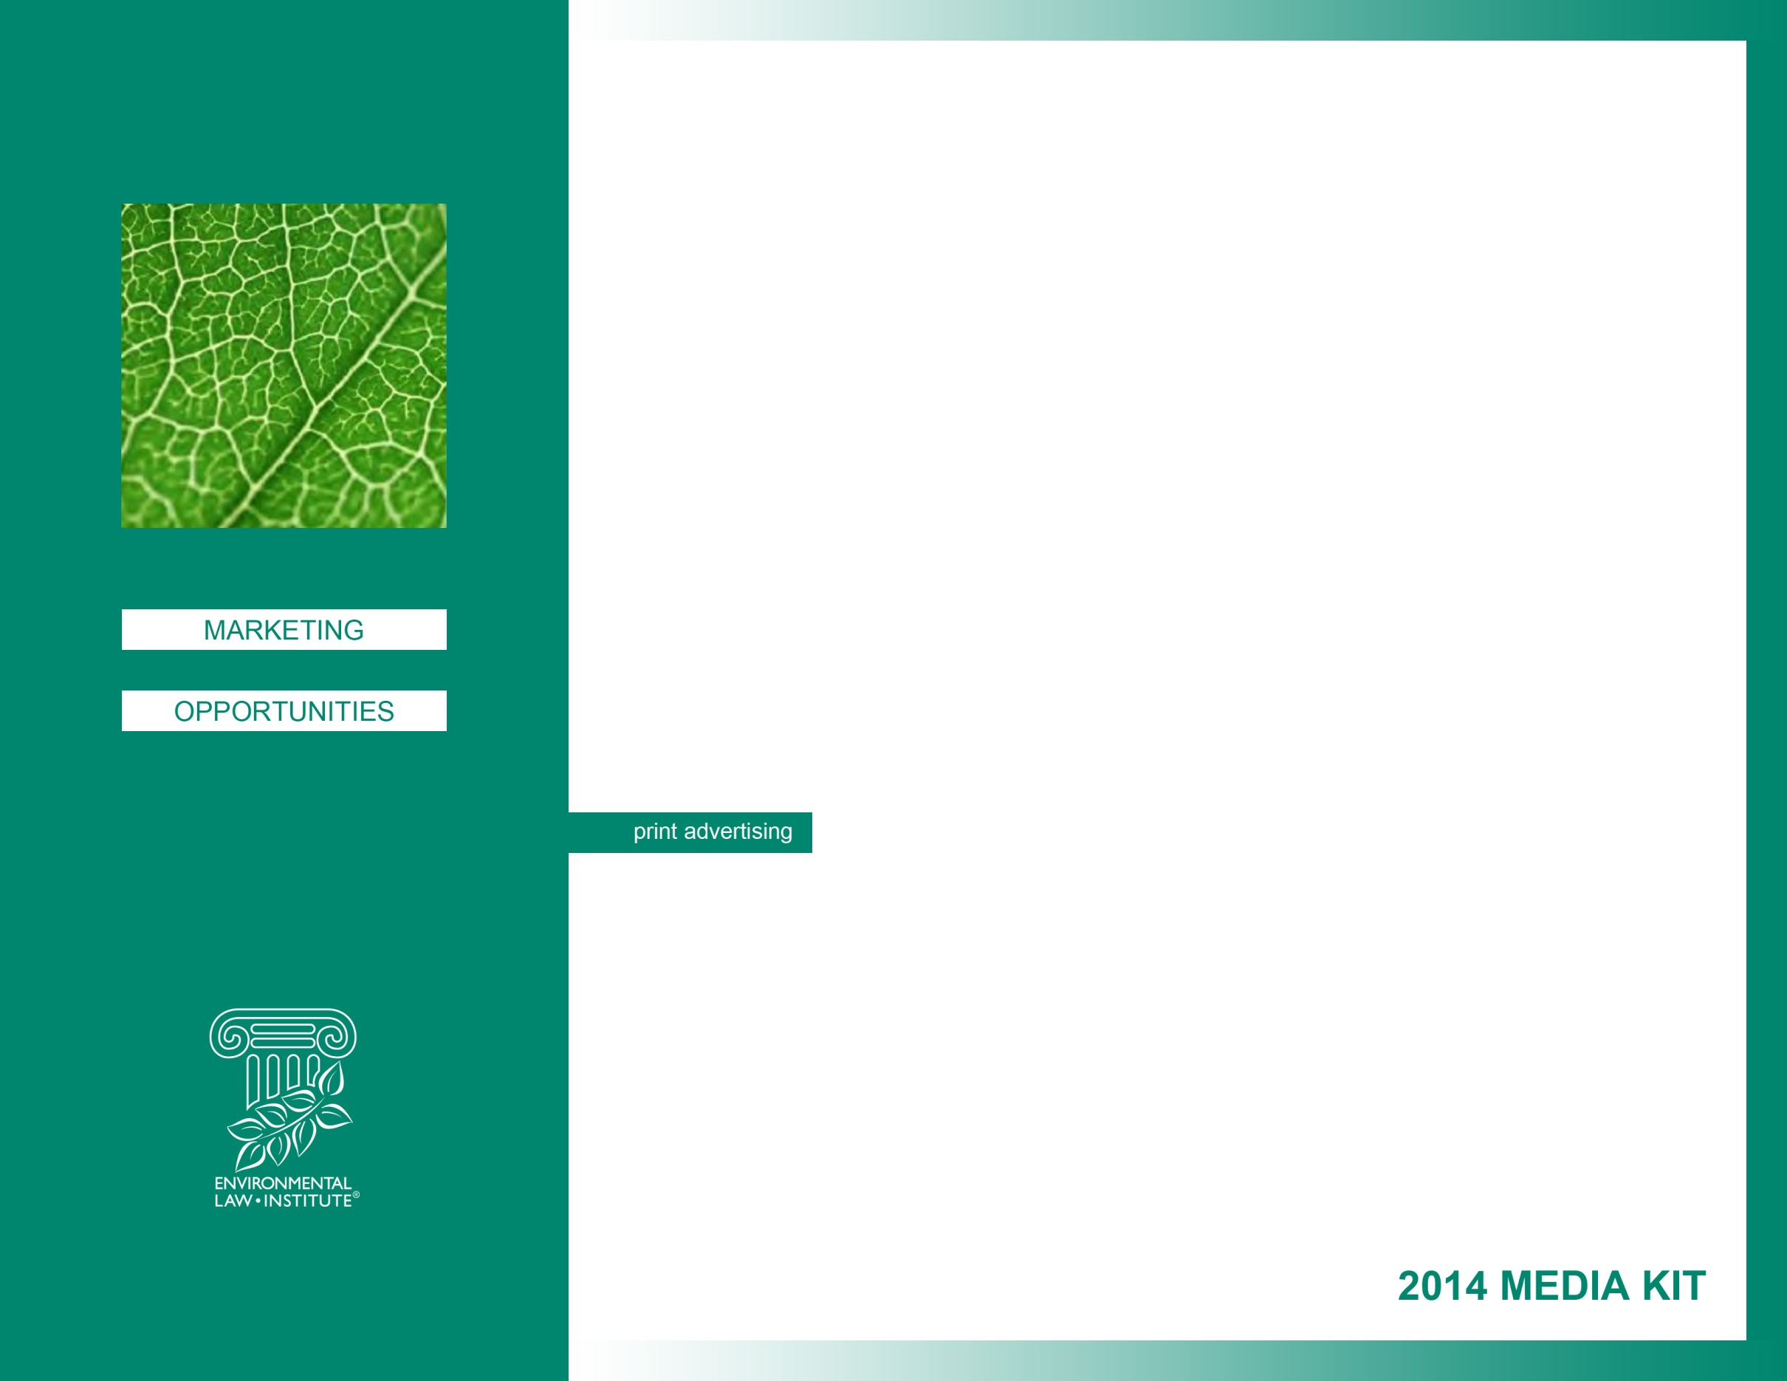
Reach the movers, shakers, and decisionmakers in the fields of Environmental Law, Policy Development, and Implementation.
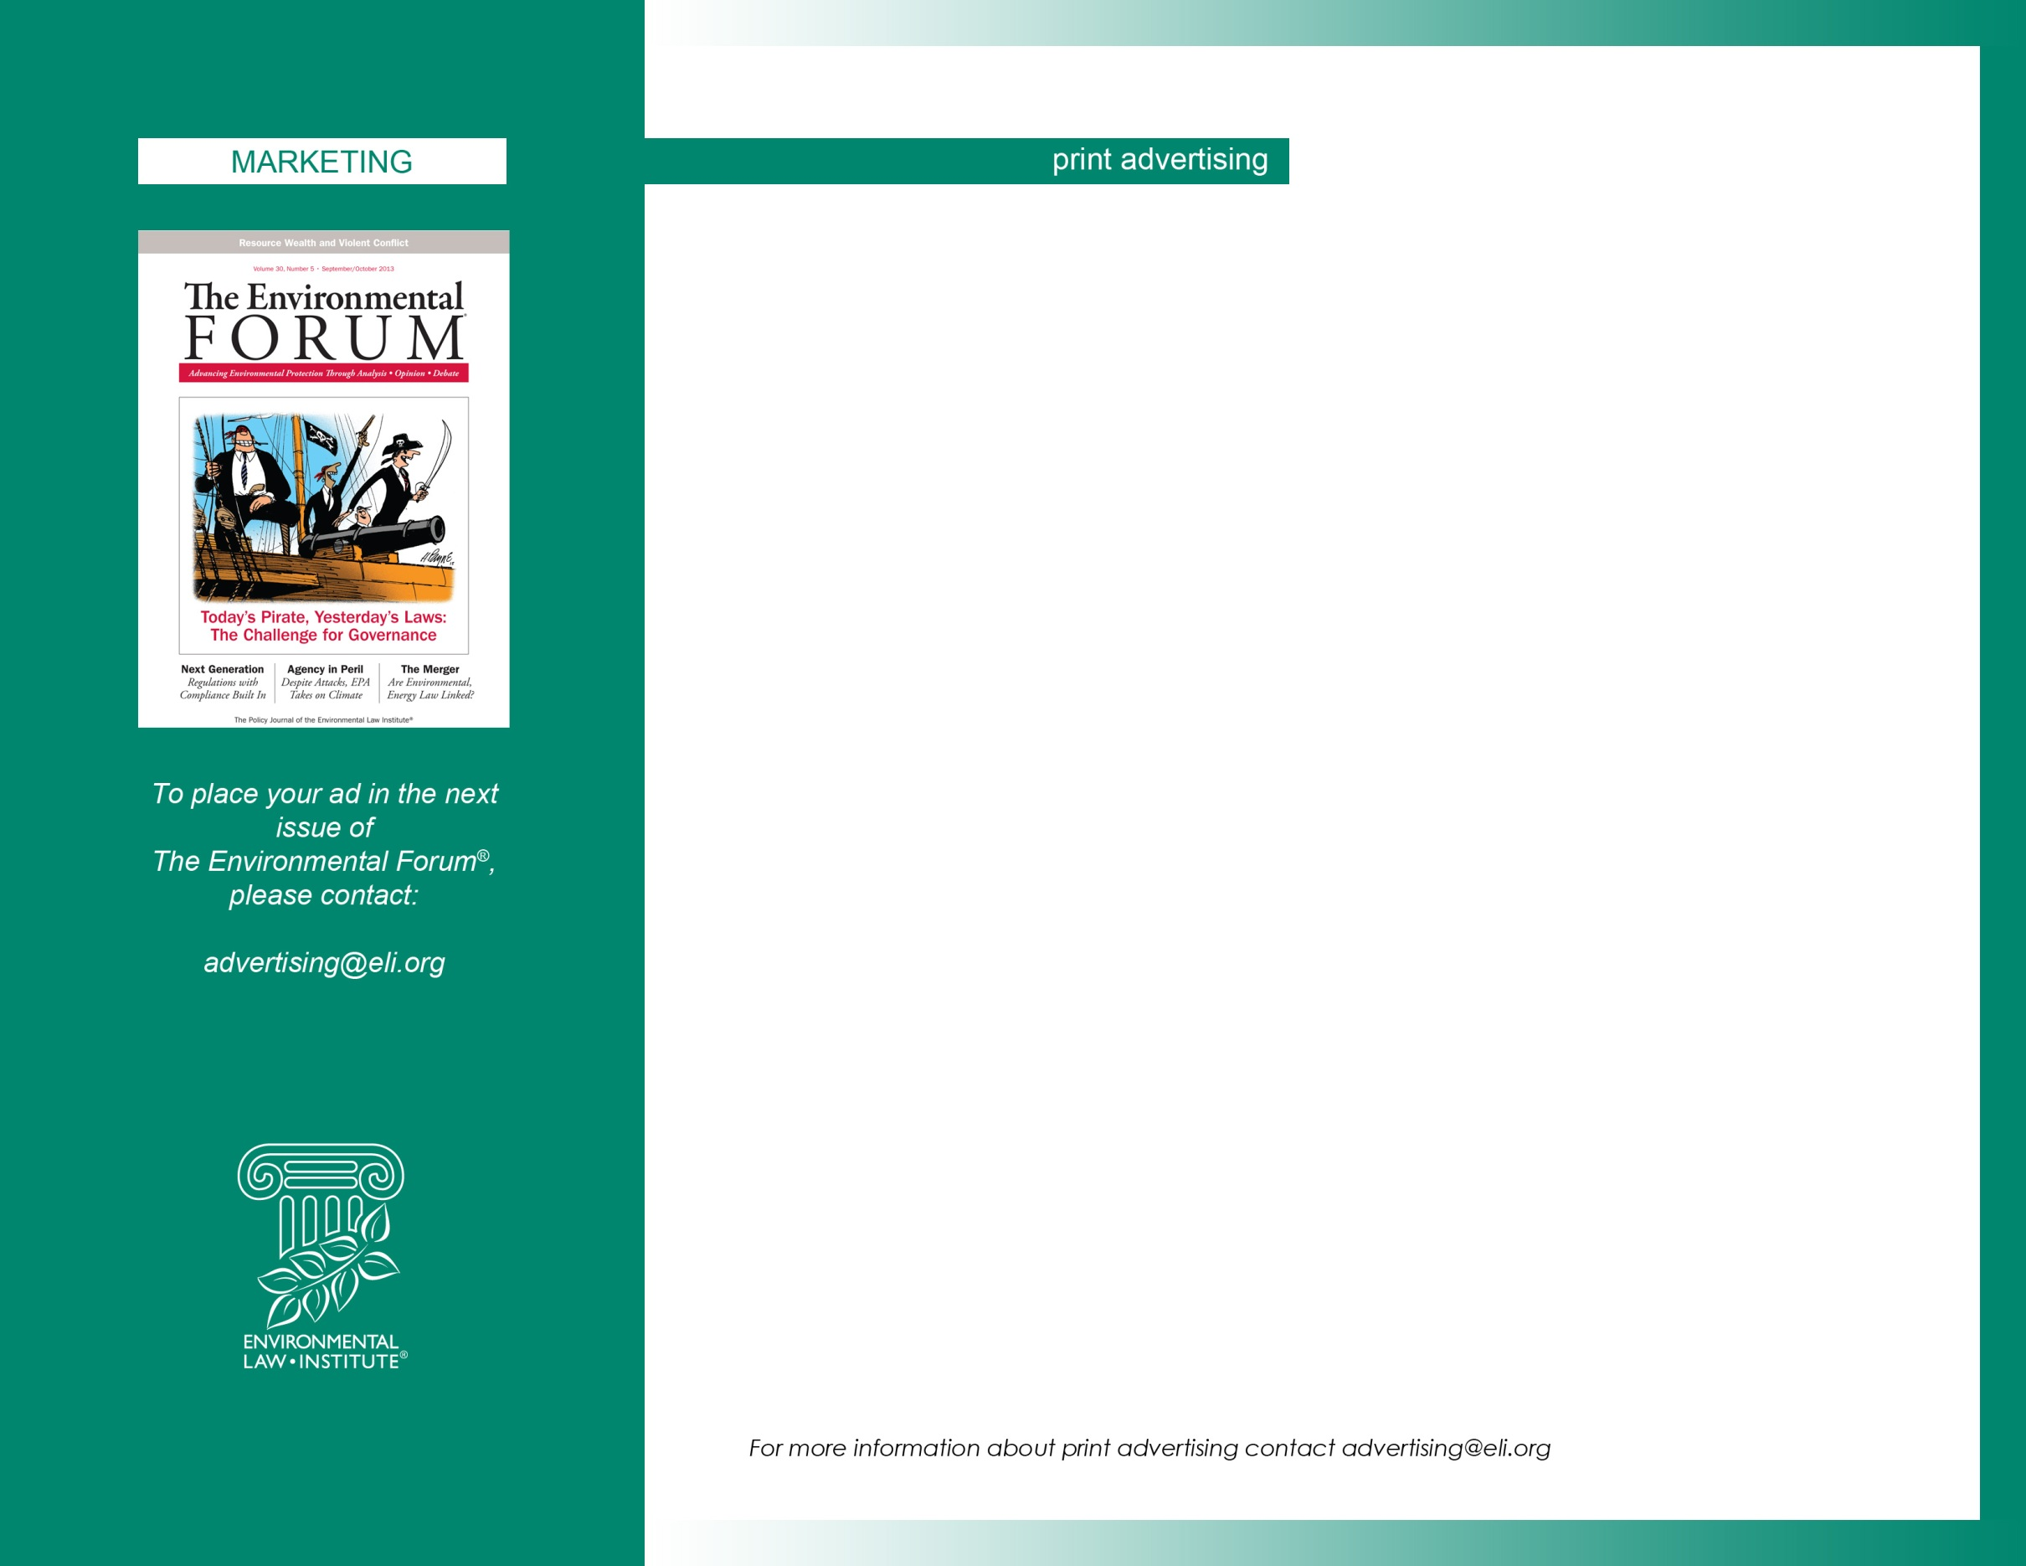
THE ENVIRONMENTAL FORUM®
Published bi-monthly. The publication of the Environmental Law Institute’s Associates Program draws together professionals in environmental law, policy, and management. The Forum seeks diverse view and opinions to stimulate a creative exchange of ideas, and exemplifies ELI’s commitment to dialogue with all sectors.
COMMISSION AND CASH DISCOUNT  15% to agencies. Net 30 days.  No cash discount.  GENERAL RATE POLICY  No cancellations after order closing date.  BLACK/WHITE RATES  1 page 1x 3x 6x  750 675 610  COLOR  4/C, per pg, extra 500.  COVERS  All inside covers are full page only, extra 500.  4/C available.  BLEED  Only spread or full pages may bleed.  1pg 8-1/4 x 11-1/8  2pg spread 16-1/2 x 11-1/8 | NON-BLEED STANDARD PAGE DIMENSIONS  Printing Process: Offset Full Run. Trim size: 8-1/8 x 10-7/8  Binding Method: Saddle-Stitched.  1pg 7-1/8 x 9-7/8  ISSUE AND CLOSING DATES  Issue: Space Material  Jan-Feb 14 11/24 12/1  Mar-Apr 14 1/25 2/1  May-Jun 14 3/25 4/1  Jul-Aug 14 5/25 6/1  Sep-Oct 14 7/25 7/25  Nov-Dec 14 9/24 9/28  CIRCULATION (est.)  Total Non-Pd Paid (Subs) (Single) (Assoc)  2,650 320 2,330 975 … 1,355  Editor: Stephen Dujack (434) 296-3380  Publisher: John Cruden (202) 939-3855

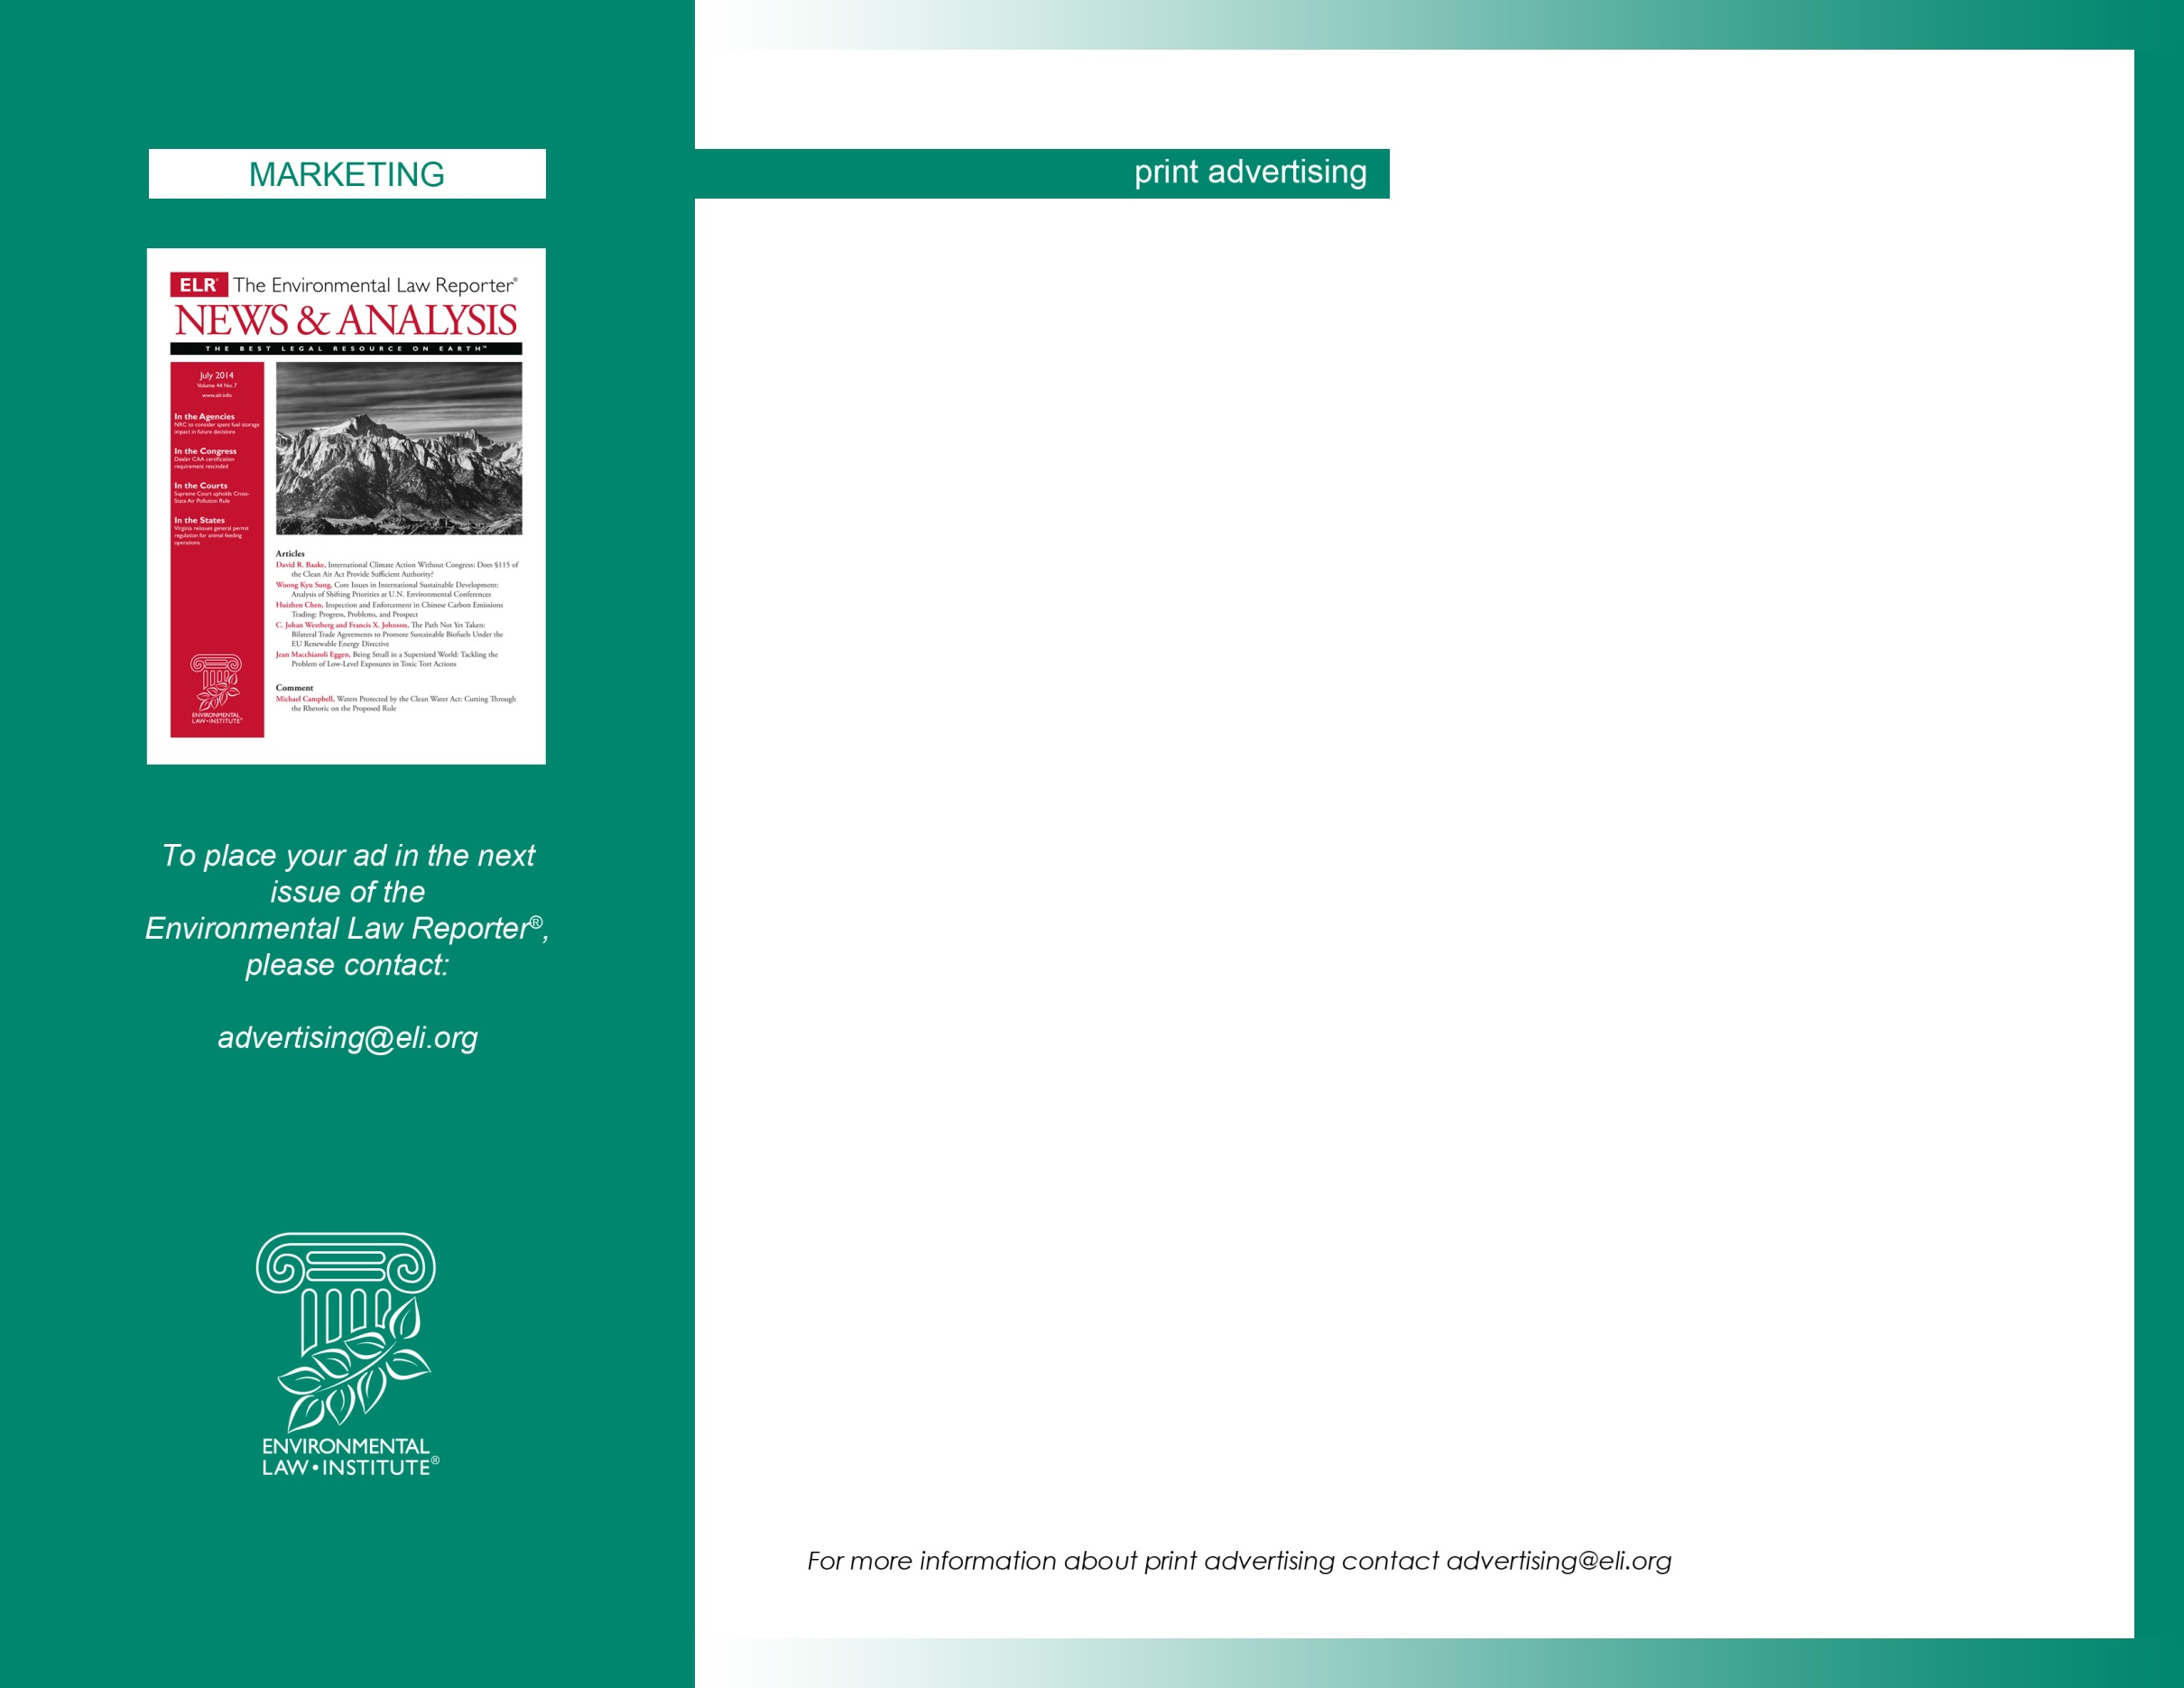
THE ENVIRONMENTAL LAW REPORTER® (ELR) News & Analysis
ELR® is the most often cited environmental law journal according to Washington & Lee University. ELR consists of continually updated, password-protected internet data and document collections, daily e-mailed updates, and a monthly print journal (News & Analysis).
COMMISSION AND CASH DISCOUNT  15% to agencies. Net 30 days.  No cash discount.  GENERAL RATE POLICY  No cancellations after order closing date.  BLACK/WHITE RATES  1x 3x 6x  1 page 350 315 285  1/2 page 250 225 200  1/4 page 195 175 150  COVERS  Inside covers are full page only, extra 500.  BLEED/NON-BLEED dimensions allowed.  Bleed 1 pg 8-3/4 x 11-1/2  NON-BLEED 1pg 8-1/4 x 10-1/2  Outside Back Cover, extra 250.  Bleed 8-3/4 x 7  NON-BLEED 8-1/4 x 6-1/2  CIRCULATION (est.)  Total Non-Pd Paid (Subs) (Assoc)  500 100 400 300 100 | NON-BLEED STANDARD PAGE DIMENSIONS  Printing Process: Offset. Trim size: 8-1/2 x 11  Binding Method: Saddle Stitched/Perfect Bound  1 pg 8-1/4 x 10-1/2  1/2 pg 8-1/4 x 5-1/4  1/4 pg 4 x 5  ISSUE AND CLOSING DATES  News & Analysis is published monthly.  Issue: Space Mat’l Issue: Space Mat’l  Jan 14 11/22 11/27 Jul 14 5/23 5/30  Feb 14 12/20 12/27 Aug 14 6/20 6/27  Mar 14 1/24 1/31 Sep 14 7/24 7/31  Apr 14 2/21 2/28 Oct 14 8/22 8/29  May 14 3/21 3/28 Nov 14 9/19 9/26  Jun 14 4/18 4/25 Dec 14 10/24 10/31  Managing Editor: Rachel Jean-Baptiste (202) 558-3101  Editor-in-Chief: Scott Schang (202) 939-3865  Publisher: John Cruden (202) 939-3855

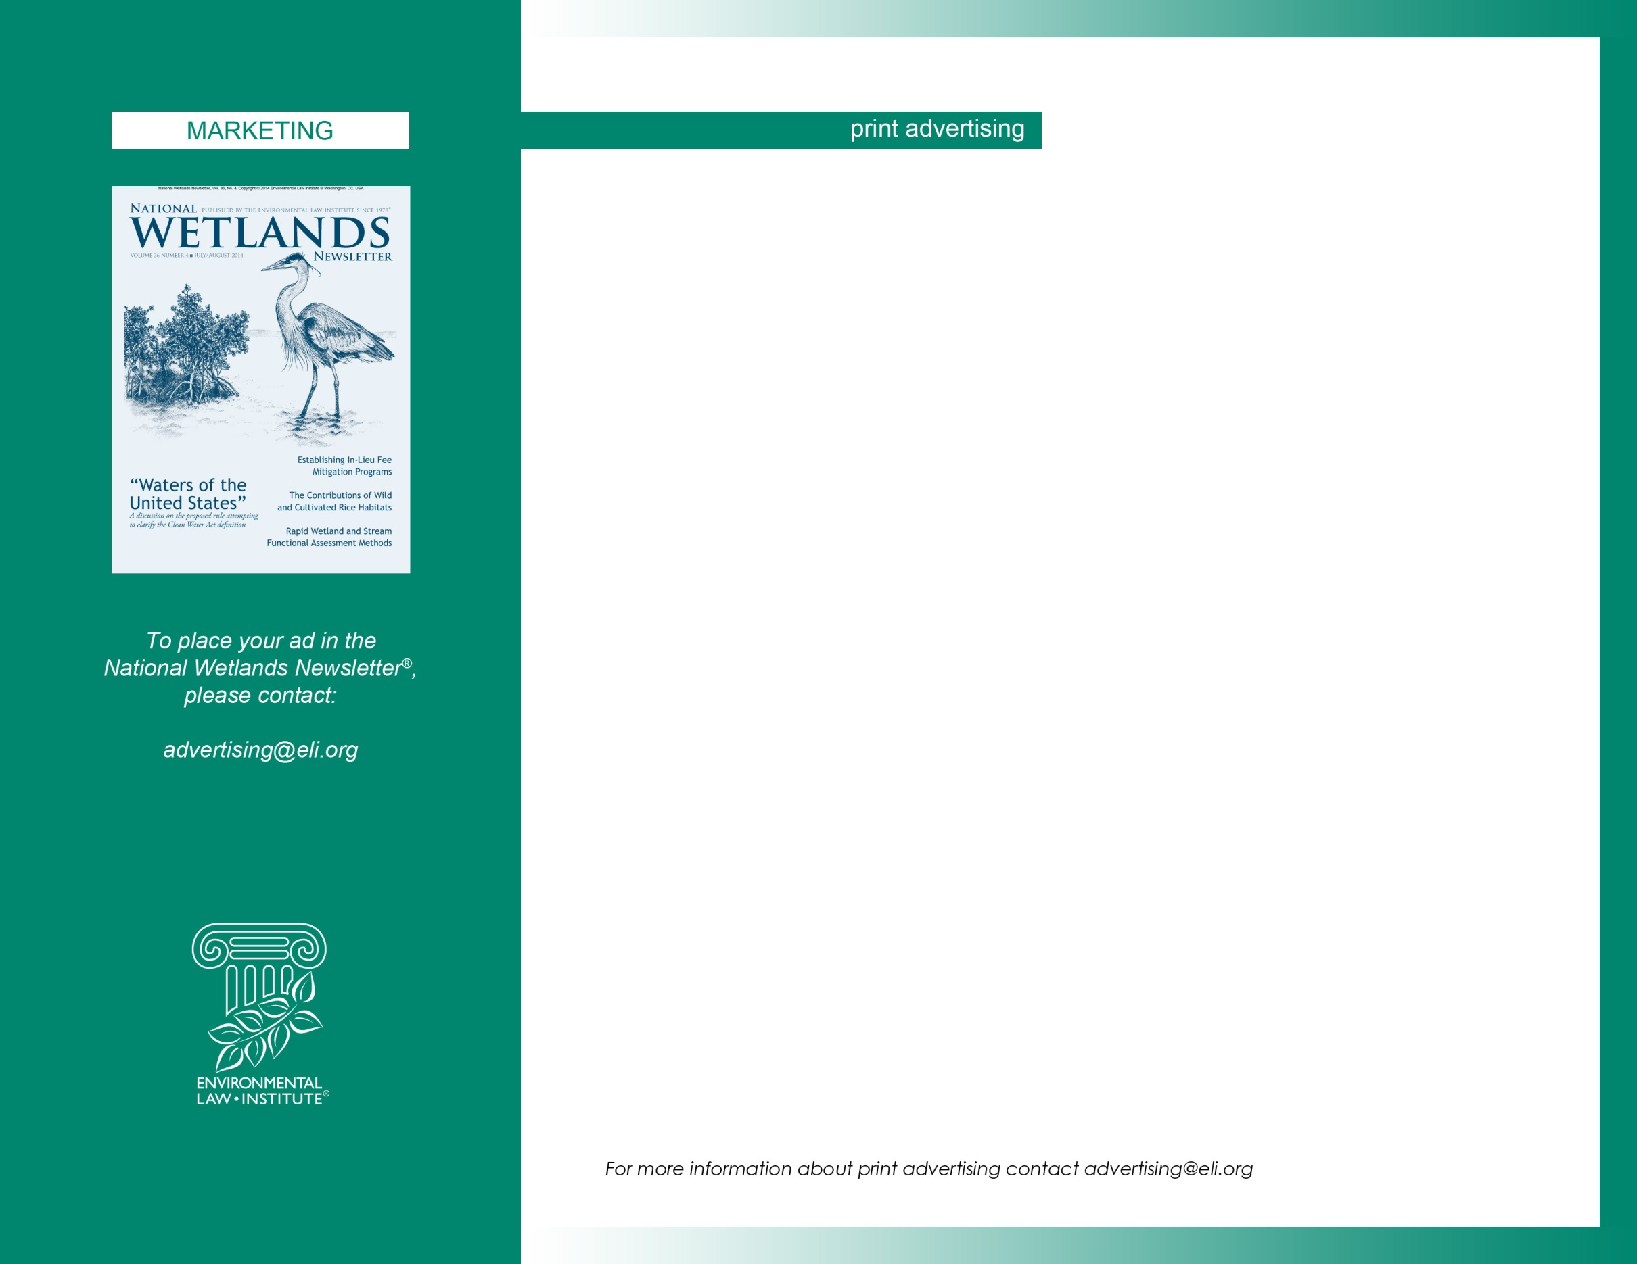
NATIONAL WETLANDS NEWSLETTER
For more than two decades, the National Wetlands Newsletter has been serving the wetlands community as the best source of accurate, timely, and in-depth coverage of wetland regulation, policy, science, and management. Six times a year, the newsletter reports on issues dominating the wetland agenda.

The Newsletter also provides valuable information that doesn’t always make the front page—including innovative wetlands management efforts, recent scientific advances, pertinent court decisions, congressional action on wetland summaries of federal agency activities, and news briefs from across the country and around the world.
COMMISSION AND CASH DISCOUNT  15% to agencies. Net 30 days.  No cash discount.  GENERAL RATE POLICY  No cancellations after order closing date.  BLACK/WHITE RATES  1x 3x 6x  1 page 350 315 285  1/2 page 250 225 200  1/4 page 195 175 150  CIRCULATION (est.)  Total Non-Pd Paid (Subs)  600 100 500  Editor: Kathryn Campbell (202) 939-3806  Publisher: John Cruden (202) 939-3855 | NON-BLEED STANDARD AD PAGE DIMENSIONS  Printing Process: Offset. Trim size: 8-3/8 x 10-7/8  Binding Method: Saddle Stitched  1 pg 7-3/8 x 9-5/8  1/2 pg 7-3/8 x 5  1/4 pg 3-3/8 x 5  OUTSIDE BACK COVER  BLEED/NON-BLEED allowed, extra 250.  Bleed 8-1/2 x 7-1/8  NON-BLEED 7-3/8 x 6-1/2  ISSUE AND CLOSING DATES  National Wetlands Newsletter is published bi-monthly.  Issue: Space Material  Jan-Feb 14 10/21 10/28  Mar-Apr 14 12/20 12/27  May-Jun 14 2/21 2/28  Jul-Aug 14 4/21 4/28  Sep-Oct 14 6/23 6/30  Nov-Dec 14 8/22 8/29

